# Findings

In this section we will discuss the results of our interviews addressing the quality of life in Venice. Our findings are presented in four sections, Interview Findings, Overall Findings, Findings by Demographic, and Cases of Interest.

## Interview Findings

We completed 28 interviews while in Venice, 6 of which were with Mestre residents. We conducted the interviews over a three week period for approximately 3 hours a day. It was very difficult to find Venetians who spoke enough English to answer our questions and who had the time to help us. Therefore only one in eight propositions was successful. We found that many people attempted to speak to us in order to help. Unfortunately, due to the complex nature of our questions, they were unable to fully answer them. Following each interview, the interviewers’ notes were transcribed with direct quotes from the interview (See ). As described in section , a coding process was used to categorize the quality of living topics.

## Overall Findings

Below is a word cloud (Section ) summarizing the all the phrases mentioned during our interviews. The word cloud includes the likes and dislikes of the Venetian populace. These are not considered to be quality of life topics, but simply general words or phrases that were mentioned throughout our interviews.



Figure : Overall Results

### Favorite Aspects of Venice

The question “What is your favorite part of Venice?” was intended to determine what Venetians value the most about where they live. The most frequent responses were categorized under community life and pace of life.



Figure : Word Cloud of Favorite Aspects

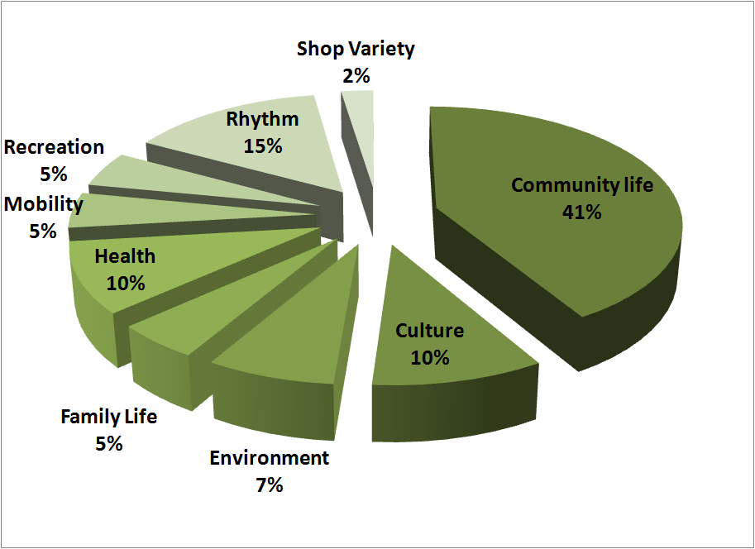

Figure : Favorite Aspects of Venice Pie Chart

Venetians specifically mentioned the *sestieri* they grew up in and the connection they still have with the people. Of the 37% of Venetians that mentioned community life as an important quality of life topic, the majority of them grew up in Cannaregio. These Venetians explained that Cannaregio was one of the only *sestieri* left that still had a true Venetian neighborhood and culture. Furthermore, the second most frequent topic Venetians discussed was pace of life. The pace of life (categorized as rhythm in the pie chart) in the Historical Center of Venice is slower than Lido and the mainland. The absence of cars, location in the lagoon, and separation from the mainland are the main contributors to the slower lifestyle in Venice. People walk around to get from place to place, which many said they enjoy because they frequently run into friends on the street. We discuss our analysis of this trend of answers in Section of our project.

### Least Favorite Aspects of Venice

The second question of the interview was intended to expose characteristics of Venice the interviewee did not favor. The majority of the responses were regarding cost of living and housing.



Figure : Word Cloud of Least Favorite Aspects

Cost of living and housing populated more than one third of all the responses to this question. At least half of the people who mentioned cost of living and housing had recently moved out of Venice. Many people ended up moving to either Lido or Mestre. The main motivation for moving is that the cost of living is too high for the average Venetian to afford. (Cost of Living, Section 5.2) Venetians who discussed community life, shop variety and tourism as problems believed that the Venetian government has not done enough to help with these situations.

. 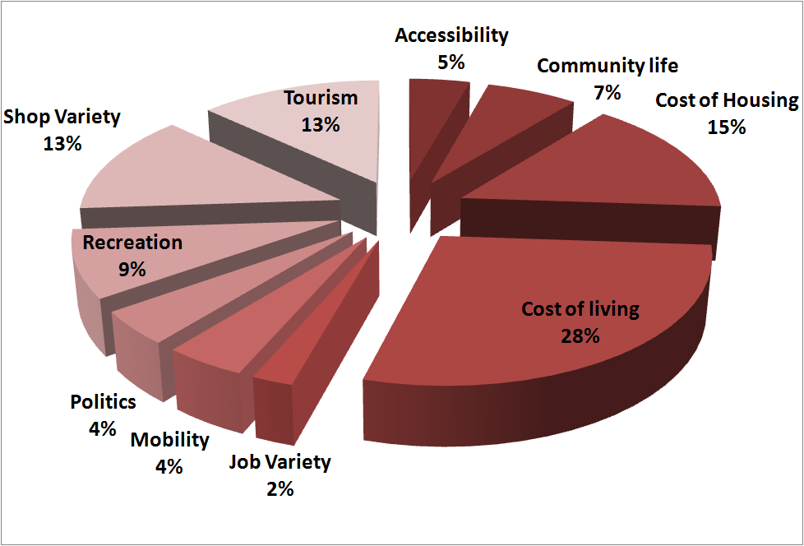

Figure : Least Favorite Aspects of Venice

### Aspects Venetians Would Like to Change

We asked Venetians what they would like to change about Venice. About two thirds of the responses addressed cost of housing and living to be the first thing they would change.

Figure : Word Cloud of Aspects Venetians Would Like to Change

Many Venetians complained about the lack of shops necessary for day-to-day living. Venetians feel that there is a lack of shop variety in Venice and that they find themselves often going to other places, such as the mainland, for certain goods. This topic will be more thoroughly discussed in the chapter.

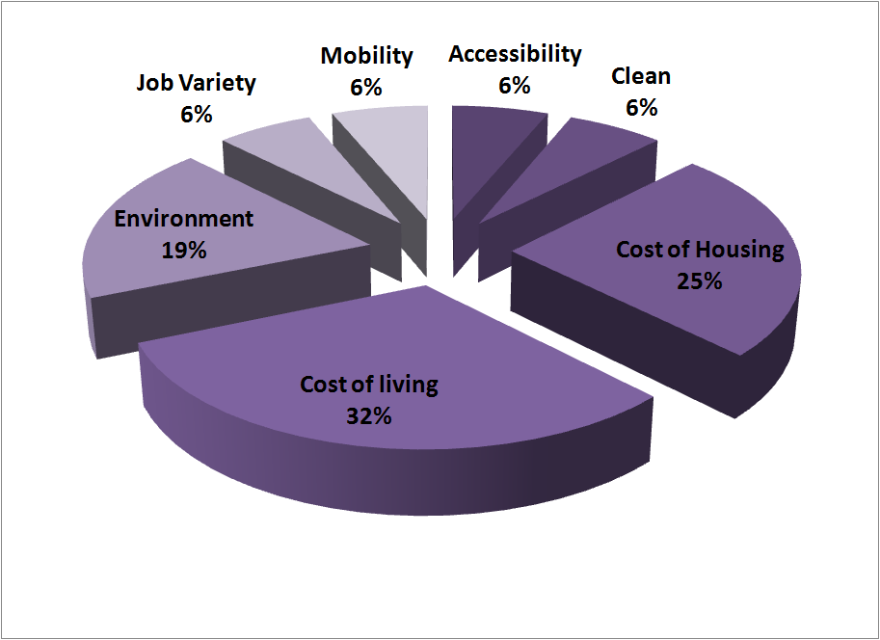

Figure : Aspects Venetians Would Like to Change

### Most Important Quality of Life Topic

 The “What do you think is most important to your quality of life?” question was designed to find out the quality of life topic most important to the interviewee. The most frequent answers were safety and community life.

As seen below, Figure 22 shows the distribution of topics mentioned by Venetians. There was much more variety of topics mentioned, including safety, health, family life, and culture. These include some of the more positive aspects of Venice not mentioned previously. The reoccurring topics will be further discussed in the Analysis section.

Figure : Word Cloud of Most Important Quality of Life Topic

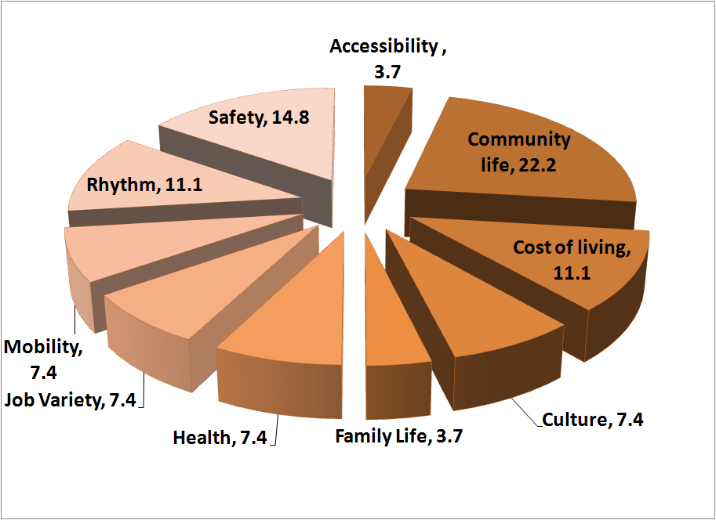

Figure 22: Most Important Quality of Life Topics

## Findings by Demographic

From our interviews, we were able to construct word clouds and bar charts based on the following demographic separations: male and female, 17 – 30 years old, 31 – 50 years old, 51 years old and older, current residents, and people who have moved to Mestre. Based on each demographic section, we were able to compare the word clouds and draw out key trends. The word clouds were used to depict the frequency of the “keywords” found in our interviews. There were a total of 39 different keywords/phrases that we took from our interview responses. The keywords were then placed under the 10 different Quality of Life topics from the *Economist*, Urban Audit, and Mercer.

The bar charts rank the percentage of the quality of life topics mentioned by each demographic. For example, politics came up twice in our interviews, raised both by men. Therefore, males make up 100% of the political responses. The bar chart and word cloud show different information but support each other’s findings.

### Male and Female

The following section contains a word cloud and bar chart comparison between male and female responses from our interviews.

#### Comparison between Male & Female response frequency

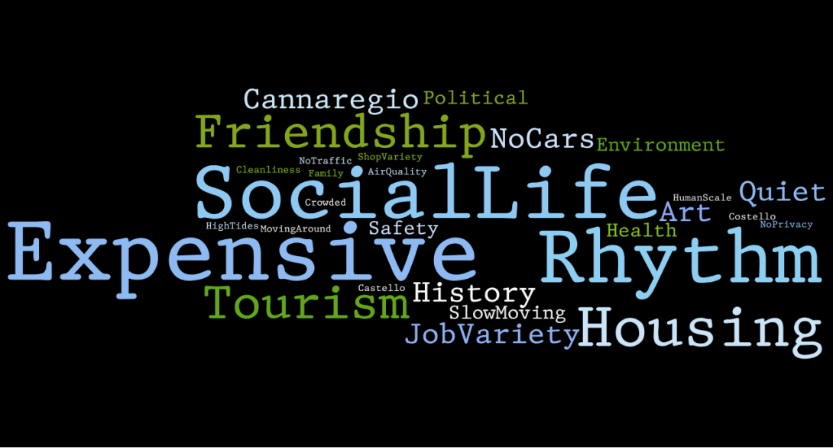

Figure : Male Word Cloud



Figure : Female Word Cloud

Both men and women agree that Venice is expensive. From food to clothes to energy utilities, everything costs more than it does on the mainland. We go into further detail about this in Section 5.2.

Males also mentioned other aspects of the city including social life, cost of housing, and the pace of the city. Venetians felt that the social life in the city of Venice is poor. All of the men we interviewed essentially said something similar. The city’s pace of life was brought up by 66.7% of men we interviewed. Men seemed to notice the slower pace of life and it appeared that it was more important to men than women. Males also believed that housing was a very important factor. Some of the men were looking to buy a home for their family, but were having problems because of the scarcity of affordable housing.

On the other hand, women felt that the shop variety in Venice was very limited. They said that the city lacked shops that offered the basic necessities for living. Women also brought up tourism as a problem. Many of the women we interviewed believed tourism was the reason why the variety of shops has decreased. This claim will be further discussed in Section 5.2.

#### Relative Importance between Men and Women



Figure : % Dislikes for Women

The charts show that 61.5% of people who disliked the high cost of living were women. This trend is also the same for shop variety. When compared in the Word Clouds above, the words for cost of living and shop variety are larger in the women’s cloud than the men’s cloud. This suggests that women were more interested in these topics than men.

Figure : % Dislikes for Men

As for the male demographic, both recreation and cost of housing were more important than in the female demographic. Again this trend can be seen in the word clouds as both the words for cost of housing and recreation were larger in the male cloud than the female cloud. As far as men were concerned, Venice lacks a fun social environment and affordable housing. Both men and women connected many of their dislikes of the city to the increased tourism. Tourism is twice as large in the male chart than the females. However if we go back to the Word Cloud comparison, the word tourism in both clouds is about the same size. This is due to the fact that we ended up interviewing more men than women. Therefore even though males made up a higher relative percentage, the importance of tourism is similar between the two demographics.

### Young, Middle Aged and Old

The follow section contains word cloud and bar chart comparisons between 17 – 30 years old and 31 – 50 years old. There is a small section on those above the age of 50.

#### Comparison of the 17-30 and 31-50 Word Clouds



Figure : 17-30 Word Cloud

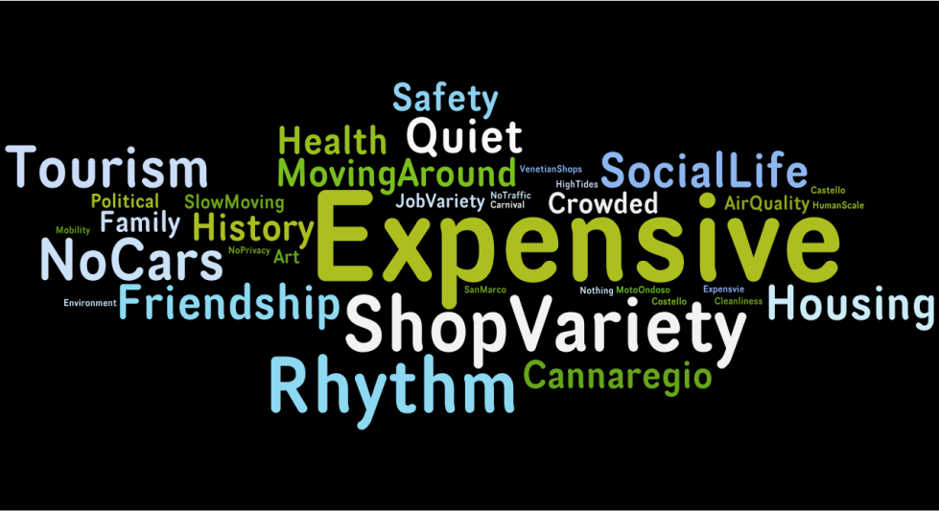

Figure : 31 - 50 Word Cloud

Throughout the two age groups, cost of living was the most frequently mentioned topic. The most prominent issues facing young people were social life and housing. The young people complained that in order to have a fun time at night, most of the time they would have to travel to the mainland. Many of the young people also talked about how they may leave the city because they cannot find an affordable place to live.

The middle aged bracket mentioned shop variety and pace of life as two important topics. These trends are similar to those in the male and female words clouds. Since the majority of our interviews were from 31 - 50 year olds, we expected that the trends in this word cloud would be some of the more common problems and pleasures. This is not surprising because the age group that makes up the largest percentage of Venice’s population is the middle aged bracket, from about 31 – 50 years old.

We interviewed two people over 50, but since we could not draw pertinent conclusions from the elderly word cloud, we did not analyze it. Two interviews do not give us enough information to effectively analyze the data.

#### Importance Analysis between the Age Groups





Figure : 17- 30 Dislikes

Figure : 31 - 50 Dislikes

Many of the trends that are evident in the bar charts are also apparent in the Word Clouds. A total of 83.3% of all people who complained about the variety of shops are in the middle aged demographic and shop variety is one of the largest phrases in the 31 – 50 year old word cloud. The highest percentage (50%) of people against tourism is from the middle aged bracket. In addition 100% of the people who disliked the job variety in Venice were middle-aged. Middle age people make up the majority of the employees in Venice and therefore they would complain about the topics that influence the job market.

### Current Residents vs. Moved to Mestre

The following section contains a word cloud and bar chart comparison between current Venetian residents and people who live/have moved from Venice to Mestre.

#### Comparison between Venetians and people who have moved to Mestre

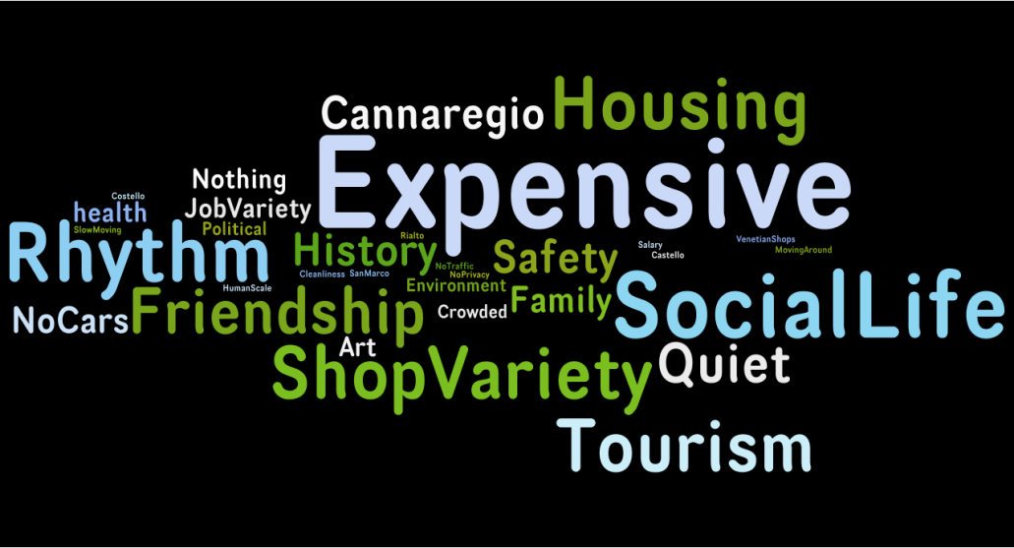

Figure : Current Residents Word Cloud



Figure : Moved to Mestre Word Cloud

This demographic comparison shows that the main reason why people have moved out of Venice has been because of the high cost of living. This conclusion can be drawn from the word cloud of people who have moved out of Venice and are currently living in Mestre.

People who have moved out of the city did not recognize pace as an important issue, but some of our interviewees mentioned that the influence of cars makes life more hectic and stressful. However, some of the interviewees noticed that the more relaxed life in Venice makes everything move slower. An example from our interviews is that construction projects take a long time to complete. People said that time management was very important to Venice as well because walking and the boat taxis are slow. Even though the pace of life in Venice is much more relaxed than Mestre, other topics such as cost of living and housing were more significant and made people leave Venice.

#### Importance Analysis between Venetians and people who have moved to Mestre



Figure : Venetian Likes



Figure : Moved to Mestre Dislikes

Of the people whom were interviewed, 70% of people who enjoyed the community life were current residents. Venetians expressed the importance of community and friendship as being the main factor that has kept people in Venice. The people we interviewed that moved to Mestre based their decisions to leave on the high cost of housing and living. According to our findings, the main reasons why people left Venice and are the cost of living, mobility and the availability of jobs in the city.

### Other Trends

This section contains other trends that were not included above, but we felt were important to mention or explore more in detail.

#### Native Parents vs. Non-Native Parents

The last demographic we were able to separate in our interviews was whether or not the interviewee’s parents lived in Venice. The word clouds that we generated for this demographic were very similar to the word clouds that we generated for the living in Venice demographic. Only two of the people we interviewed whose parents did not live in Venice lived in Venice themselves. Seeing this, there was very few differences for us to analyze in this demographic.

These bar charts were also very similar to the previous demographic. The four highest percentages for the interviewee’s whose parents were not from Venice were accessibility, job variety, cost of living, and cost of housing. These four trends have been consistent factors that force people to move out of the city.

#### Community Life

Community life turned out to be one of the most important quality of life factors in Venice, but the Word Clouds do not express its importance. In the Word Clouds the phrases such as friendship, Cannaregio, Castello, San Marco, Rialto, and family life are all under the quality of life topic for community life. Therefore even though the individual words may be fairly small compared to the word expensive or shop Variety, the number of all of the community life topics makes it the most important quality of life factor in Venice

#### Politics

Even though only two of our interviews touched on politics, it appeared to be a fairly important topic. Venetians feel that the gondoliers and taxi drivers have a significant influence in the government and can shape the policies in Venice. However, when we asked people about what the government has been doing to improve life in Venice, they complained that not much done. Overall it seems as if politics in Venice seems to be a good field to explore.

## Cases of Interest

Below is an account of two of the interviews we conducted. We found these interviewees to have particularly interesting responses and good insight to the questions we were asking. For privacy reasons we changed the names of the interviewees, but all other information is their personal information.

### Mary

One of our first interviews was Mary. She was a twenty four old Venetian who had lived in Venice for all of her life and whose parents were from Venice. What was most interesting about her was that despite having a degree in political science from the University of Padua, she worked in Venice as a waitress. She stated that she had tried pursuing secretarial positions in Venice, as they were all that was available to her, but was unable to get any.

It turned out that as a waitress she worked full time with additional overtime and was still not able to make ends meet and, as a result, still lived with her parents. She told us that the cost of living was simply too high and she never had any money to spend on little things for herself or a night relaxing and drinking with friends. Mary knew that this was a problem that was specific to Venice as she spent a year abroad in Australia. There she was still able to work as a waitress, did not have to work overtime, and had more than enough money to make ends meet.

One thing in particular that bothered her about Venice was the disturbing lack of a youth culture. She said that other than simply going to a bar to drink with friends, there was nothing for her to do. Even then, not many young people were active in Venice at night, leaving her with few people to meet and hang out with. She complained that many of the people in Venice were simply too old and described them as “uptight”. She said she found it hard to relate to many of the older members of the city.

She described Venice as a wonderful “old city” and stated that “she wanted to live here, grow old here, and have her children here.” Unfortunately, she explained that there was simply not much of a youth culture in Venice anymore and the cost of living coupled with the job market made life difficult for her. Mary didn’t mention any plans for leaving the city, but from talking to her, one got the sense that there would soon come a point when she would have to leave the city to try and pursue her career.

### Kyle

One of the cases that we found particularly interesting was Kyle. Andrea is a 31 year old male who lives in Mestre, but works in Venice. Despite the fact that he has never lived in Venice, Kyle attended the University of Venice and through this made contacts to get a job. During our interview we were able to find out some of the major differences between life in Venice and life in Mestre. Andrea was a very good case to study because he was able to tell us about living in both cities and what it is like to live on the outside of Venice, but work on the inside.

According to Kyle life in Venice is very different from life in any other place. “Venice is like a bubble and you have to think differently in order to live here.” We found this to be interesting because other interviewees that made a similar statement. One of our other interviewees even went as far to say that “Venice is like an Indian Reservation” because the city is so closed off from many other places. An interesting correlation between this is that the other interviewee also lives in Mestre.

Although there were many advantages to living in Venice, there were also many disadvantages to living in Venice. There are no cars, which not only allows people to walk everywhere, but also creates a cleaner environment. Venice is also a no stress, relaxed environment. One of the disadvantages to living in Venice is that the job market is very small. “If there is an overpopulation of one particular skill, people will have to leave in order to find jobs.” It is also very expensive in Venice, which forces many people to move out because they cannot afford it. He also mentioned that it takes you a lot of time to do anything, whether it is from going from one place to another or waiting in line in a store. Kyle stated that “in order to live in Venice you cannot be concerned with either time or money.”

Kyle also mentioned the advantages and disadvantages to living in Mestre. One of the advantages to living in Mestre is that you can have a car so that if you wanted to go someplace you didn’t have to concern yourself with how long it was going to take you to get there. A downside to this, however is that life is very “frantic” and “not relaxed at all.” Kyle stated that “you don’t ever have to wait in lines” which simultaneously an advantage and disadvantage. Due to the fact that Mestre has cars, “parking and noise” are a big issue. There is also a lack of job variety there as well. “If you want to work in a factory you work in Mestre, but if you want to work with either Art or Tourists you work in Venice.”

Our interview with Kyle helped to get an insight into life in both Venice and Mestre. This allowed us to see some of the differences between the two cities. Many people start out living in Venice and then relocate to Mestre due to the high cost of housing, but it is different if a person was born and raised in Mestre and stayed there.

# Analysis

In this section, we will elaborate on the prominent trends that seemed to emerge from our results and will discuss our analysis and extrapolation of these trends. The most dominant trends were the issues of housing and hotels, cost of living, pace of life, community life, and population decline.

## Housing and Hotels

Through our interviews Venetians expressed concern about the increase of hotels and lack of affordable housing.

Much of the housing market is focused on non-residents opposed to residents of Venice. In 1971 there were 3.1 % of homes occupied by non residents. In 2008, homes occupied by non residents increased to 19.4%. [1] A nonresident does not live in Venice all year. Typically nonresidents own vacation homes. Venetians feel that there is a correlation between the number of nonresidents and cost of housing. In the Historical Center of Venice housing is 300% more expensive than the average resident can afford. [2] Therefore, many residents cannot afford to live in the Historical Center and are being forced to move. We found that the main two places that people move to are Lido and Mestre. During our interviews we found that the topic housing was always mentioned as a negative.

The cost of housing affects Venetians of all ages. The younger interviewees mentioned that it was difficult for them to afford an apartment after graduation. Two particular cases are excellent examples of young Venetians expressing their frustration about cost of housing in Venice. The first is a woman named Mary whom we mentioned in Section 2.4.1. Mary graduated with a degree in Political Science from the University of Padua. She decided to move back to Venice because she enjoyed the lifestyle. Currently Mary is working two jobs and is struggling to make ends meet. She lives with her parents but despite her hard work, it is very difficult for her to live in Venice on her own. Another interesting interview was with Alex. Alex is 28 years old and currently lives in Lido, but works in Venice. When asked what he would like to change about Venice he stated that he “would like the prices of houses in Venice to decrease that way more young people could afford to live here.”

It is suspected that the increase in number of hotels has caused the number of affordable housing decrease. From the late 1950’s to the early 2000’s the number of hotel bed doubled to approximately 16,000 beds. The increase in number of hotels is suspected to have had a great effect on the residential housing market. After the Commune di Venezia passed Law 49 in 1999 more bed and breakfasts and hotels were able to open. Residents no longer needed governmental permission to open a hotel therefore making it easier to open a bed and breakfast to open.

## Cost of Living and Lack of Shop Variety

The high cost of living is a prominent issue in Venice. Approximately 75% of our interviewees mentioned that the cost of living in Venice is more expensive than they can afford. Utilities and Services is one area that greatly influences a person’s choice to live in Venice, especially when they are looking for a place to live. In the past 10 years the price of oil used to heat homes has risen by 90% and the price of gas used to cook food has increased by 70%. [3] The transportation of goods from the mainland to the Historical Center causes an increase in cost compared to the cost on the mainland. The average cost to transport a liter of oil to the Historical Center of Venice is 0.0173 euro. [4]

Food is one of the basic necessities that are more expensive in Venice than on the mainland. For example Calamari costs about 4 Euros more per kilo than it does on the mainland and beef is about 2 Euros more per kilo than it is on the mainland. The cost of the 32 food items used to calculate the consumer price index in August 2008 was 18% higher in the Historical Center than in Mestre. The increased price is due to the transportation costs of moving goods from the mainland to the island.

Very few basic necessity stores are still around which makes it hard to live comfortably. According to the Venetians we interviewed, the variety of traditional Venetians shops have also been affected by tourism. A previous study from 2005 (see ) collected data on the types of stores in Venice from 1970 to 2005 in Dorsoduro and Cannaregio[5].



Figure : Dorsoduro Shop Breakdown in 1970



Figure : Dorsoduro Shop Breakdown in 2005

In the *sestieri* of Dorsoduro, the percent of basic necessity stores (Appendix D – Categorization of Stores from Retail E’05 Project) has dropped from 28% in 1970 to 5% in 2005. Tourist shops, hotels, restaurants have increased greatly over the same 35 year period. Surprisingly, a quarter of the shop breakdown in 2005 is made up of closed stores. Contrary to Venetians belief, tourist stores did not cause many of the stores to close. Various hypotheses to why the amount of closed stores has been increasing were that supermarkets have taken the place of the smaller basic necessity stores, or that the rent was too expensive for new stores to open.



Figure : Cannaregio Shop Breakdown in 1970



Figure : Cannaregio Shop Breakdown in 2005

Many of the trends in Dorsoduro that were previously stated are apparent in Cannaregio as well. The percent of basic necessity stores in Cannaregio had dropped from 26% in 1971 to 6.3% in 2005. The similarities between Dorsoduro and Cannaregio express how the trend is common throughout the entire historical center of Venice. In 1970 there was only one supermarket in total in Cannaregio and Dorsoduro combined, and in 2005 there were 3 in Cannaregio and 2 in Dorsoduro. Some of our interviewees have talked about the growth of non-Venetian retail. There has been a major shift in Venetian retail. Many basic necessity/service stores have closed and have not reopened for various reasons. While these stores close, restaurants and hotels open in their place. However, many of the stores stay closed. The reason for this trend is not fully understood but many hypotheses have been made.

## Community Life and Pace of Life

From our interviews, community life/pace of life was the most frequently mentioned quality of life topic. Despite the fact that “pace of life” was not found in any of the literature we studied, it is an important factor among Venetians. We created the term “pace of life” to quickly adjust to the growing trend we found among Venetians we surveyed. What we found was that many Venetians were emphasizing what they called “the Venetian lifestyle”. Our task was to try and ascertain what “the Venetian lifestyle” actually consisted of.

Venetians often described Venice as “a social city”. Due to the lack of cars, people have to walk everywhere and this fact defines Venetian life. “Walking around the city, one runs into many different people along the way. When you see someone you know, you stop and talk to them. It also causes you to meet new people along the way”. The Venetian who quoted this described life in Venice as “mobile” and said it makes for a different social environment.

Other Venetians also described Venice as “a relaxed environment”. One Venetian said that, “Even when I’m working or doing errands, [in Venice] there’s just no stress. In another city, I would be driving everywhere and rushing around on edge”. Many Venetians mentioned that the atmosphere in Venice was different from many other places and when probed further, they would describe the atmosphere as “relaxed” and “laid back”.

Eventually one Venetian said to us, “In Venice life flows at a different pace. People walk everywhere and take the time to enjoy things. It is a different pace of life, a different pace.” It was from this quote that we took the term “pace of life” and applied it to life in Venice. The “pace of life” of Venice is the special lifestyle and atmosphere in which the people of Venice conduct their lives. This is caused by Venice’s location away from the mainland in the lagoon, as well as the lack of cars located in the historical center of Venice.

It would seem this concept of “pace of life” is very important among Venetians. Our interview results show that the frequency of “pace of life” was mentioned the most by people who had lived in the city for all of their life. If someone had to categorize the Venetian lifestyle into one concept, it would be “pace of life”.

## Population Decline

The population of the Historical Center of Venice has been on a declining for the past fifty years. It is believed that cost of living and availability of affordable housing are prominent causes for Venetians leaving the city. Another probable cause in the decrease of population not mentioned in the analysis section is job variety. In the tourist verses population graph below, the lighter line represents actual data and the darker line is our predicted data. See section 4 to refer to our prediction methodology.

Figure : Predicted Venetian Population and Number of Tourists

The job market in Venice caters towards tourism. Therefore if one is not interested in the tourism field they will have a difficult time finding a job in Venice. An interviewee said that, “you work in Venice if you are interested in working with art or tourists.” Graduates who did not major in tourism have a difficult time finding a job in Venice. As a result, many Venetians leave the city to find jobs elsewhere. As shown in our predictions above, the number of tourists will continue to increase. Therefore, Venetian graduates will continue to leave the city looking for an occupation.

# Recommendations for Future Projects

In this section we will elaborate on certain topics and issues that arose during our research that we feel should be pursued in a future project. In each section we have included our idea of perceived gaps, a suggested course of action, and some background information we have unearthed.

## Working in Venice and Commuting to Venice

During our interviews we encountered a large number of people who worked in Venice, but lived in Mestre due to Venice’s high cost of living. In one case we interviewed a woman who spent an hour driving to Venice in her car and then another forty-five minutes on a boat to get to where she worked. Mobility as an issue had arisen during the course of our interviews, but we had not foreseen it as a being a problem for commuters. As we continued our interviews, we were surprised by how many similar cases we encountered.

Although it is an important topic, no prior studies have been conducted on commuting to work in Venice. More people are being forced to move out of Venice each year to alternative locations with a less expensive cost of living. The issues of commuting to Venice for jobs seems like it will become more important as time goes on because of the ever rising cost of living in Venice. According to the Venetians that we interviewed, mobility has already proven itself to be an issue. We feel a project focused on commuting to and moving about the city should be proposed with an emphasis on Venice’s commuting population.

The questions that we feel a project like this will address are as follows:

1. How many people commute to Venice each day?
2. How large a role do commuters play in Venice’s economy?
3. Are most or all of the commuters from Mestre?
4. How long does it take the average person to commute to Venice?
5. What challenges do Venice’s commuters face?

As more and more of Venice’s native population is driven out, the number of people commuting into Venice for work seems like it will only increase. Our interviews indicate that even if most of the native population of Venice was to leave, there would still be a large job market for tourism in the city. This would require people to commute into the city to serve this job market.

## Housing in Venice

Through previous research we found that the Venetian housing market poses many problems within Venice. In our interviews we were able to confirm that the housing market is still a very large problem for both Venice and its residents. Our research suggests that the Commune of Venice does fairly well at supplying its poorer residents with low-income housing. However there is a distinct lack of affordable housing for middle-income residents. Venice’s core population is largely being driven off of the island due to the city’s housing problems. While we were aware of this issue when we went into our project, the problem turned out to be far more pervasive than we expected.

As we mentioned in the Housing and Hotels section, the problem of a lack of affordable housing for the middle class is only going to get worse as more residential housing is converted into hotels. Our Motion Chart hints the significance of the Commune di Venezia Law 49 passed in 1999. Although previous projects have been done on the housing markets in Venice, we feel that there is still a distinct need to continue to investigate the situation in order to propose solutions and provide useful data.

The questions that we feel a project like this will address are as follows:

1. What are some of the many causes of the housing problem in Venice?
2. How are those causes influencing the housing market in Venice?
3. How does the 1999 Commune di Venezia Law 49 relate to the dramatic shifts in the housing market?
4. Exactly what has the government been doing to help ease the housing problem?
5. Is tourism largely responsible for the housing problem? Why?

One of the previous housing projects we investigated focused more on how Venetians found housing and the average prices of apartments in Venice. According to our research, this project was conducted while the housing problem was still in its early stages. From our interviews we believe the housing problem has grown to such a large scale that it requires further investigation.

## Moving in Venice

Mobility in Venice has been an ongoing issue which has been researched and studied many times before. However these studies were more focused on boat transportation and the lack of cars. From our interviews we found that these two topics are not the only mobility topics that people have in mind. Numerous Venetians complained about the time it took them to get around the city not only by boat, but by walking as well. Residents from Lido or commuters from Mestre in particular talked about how aggravating it was to take 45 minutes or more to get to work in the morning or at least 15 minutes to get to the store. This was especially interesting as it was purposely mentioned in contrast to the previously mentioned social and environmental benefits. Many Venetians noted that they enjoy walking around the city and the lack of cars makes for a cleaner environment.

The Venice Project Center has conducted numerous studies about moving around in Venice. However, from what we have researched, these studies were largely concerned with traffic flow and movement patterns. From what we have seen, there is a potential project in studying the time it takes Venetians to get around the city, as well as the routes they take on the course of their average day. Measuring times such as the average Venetian’s commute to work or the time it takes a Venetian to get to the nearest grocery store may yield insights into how native Venetians move about the city. This may also give insight into the makeup of the city.

The questions that we feel a project like this will address are as follows:

1. How long does it take the average Venetian to get to where they need to go?
2. Where do the public transport systems of Venice succeed? Where do they fail?
3. What is the normal route of Venetians throughout the city based on their sestiere?
4. Does it take a long time for Venetians to move around the city? Is it a problem?
5. What are ways that travel around the city may be improved?

As many people mentioned it in our interviews, we simply felt this issue was too large to ignore. A project itself seems necessary to determine whether or not mobility around the city is an actual issue or if it exists merely in the minds of the Venetians. Such a project may end up helping to improve the lives of many Venetians in terms of their mobility.

## Politics of Venice

The most surprising response to our interview questions was from a small number of residents who brought up politics as the main problem that is plaguing the city. From what these Venetians said, the government has not been doing enough (or anything effective) to combat the problems of the city. In certain cases, the residents even mentioned the government as being an obstacle in the way of fixing the city’s problems. One Venetian argued that Venice had turned into a hierarchical society where the tourism and taxi unions possessed a large amount of influence over government decisions.

While these findings surprised us, we were also intrigued by the possible revelations that investigating these political relationships might unearth. From our interviews we have learned that the growing political power of the unchecked tourism industry and the constant influence of the taxi and gondola unions is reason why the Venetian government has been doing very little to aid the people. If certain political dynamics are creating difficulties for solving Venice’s growing woes, it may be necessary to dedicate a project to analyzing the effects of the city’s politics.

The questions we feel a project like this will address are as follows:

1. Is there government responding to needs of Venetians in different quality of life areas?
2. Do the Venetians feel that the government is responding to their needs in different quality of life areas?
3. What policies have helped the Venetians? What have hurt them?
4. Are there any political interest groups causing problems for the city? Are they any creating obstacles?
5. Do certain parts of the government have a conflict of interest?

We feel it is important to identify any problems that are impeding the government’s progress on efforts to save the city and solve issues such as the housing problem. Though taking a political stance may be dangerous for the project center, it seems as though Venetian politics are playing a large role in the future of Venice.

## Population Trends

The population in the historical center of Venice has been on the decline for the past 50 years. Through our research and interviews, we have been able to identify some of the main causes for the population decline. The topics include cost of living, job availability, housing, and tourism. We have also been able to predict the future population trends of the city of Venice, Mestre, and Lido by use of extrapolation and the motion chart. Although there are some ideas as to why the Venetian population has been dropping, there is no concrete evidence stating exactly what has reduced the Venetian population. In Lido however, the trend is somewhat different. Even though the total population in Lido is decreasing, the amount of Venetians living in Lido has been increasing.

The questions we feel a project like this will address are as follows:

1. What are the underlying causes of the decreasing Venetian population?
2. How can the current population trend be reversed?
3. What has the government done to stop the population decrease?
4. Beginning in 1991, the non-residential housing in Lido had begun to decrease. What could cause something like this to happen?

This project could potentially expose the population problem in Venice. If nothing is done to correct this problem there will be about half the number of residents living in the city by the year 2050. If nothing is done Venetians feel that Venice will be on its way to becoming a commercial historic site.

## 40xVenice

During our time here in Venice we came in contact with an organization named 40xVenice. This organization was created by a group of Venetians who are approximately in their mid 40’s. The focus of the organization is to try and preserve the Venetian life that is rapidly fading and to help improve the city. We interviewed Giovanni who is the head of the “Life in Venice” section of 40xVenice. Many of the quality of life topics that we were learning about from our interviews were important to Giovanni’s work in order to improve the city. Our work with 40xVenice has consisted of interviewing Giovanni and his attendance at our final presentation. Despite the fact that we have been studying what it is like to live in Venice, we are not residents of the city and we can only do so much to help.

This group as quoted from one of our interviews has been “a breath of fresh air”. 40x Venice can truly impact the city and potentially change the future of Venice. We believe that there should be future projects focused on helping this group in any way possible and aid them in as many ways as we can.

The project should be able to:

1. Spread the influence of the 40xVenice group throughout the entire city
2. Translate weekly meetings held by 40xVenice so that their message can be understood universally
3. Help the 40xVenice group contact the government/organizations that need to be contacted
4. Provide help with any studies or projects the 40x Venice group may be undertaking

This project is completely dependent on what the 40xVenice group is doing at the time. We feel as if this group of people can do great things for the city of Venice and that it is time well spent helping them. We believe that anything that can be done to help make this group achieve its goals should be a priority. The influence that 40xVenice could potentially have on the city could actually restore the parts of Venice that have been lost to tourism.

# Conclusions

The four main topics that are most important to life in Venice are cost of living, housing, the pace of life and the population decline.

The Historical Center of Venice is very expensive to inhabit because of its separation from mainland and location in a lagoon. One Venetian mentioned that “It is much cheaper to shop on the mainland for clothes”. On average, goods in the Historical Center of Venice are 80 euro cents more than the mainland due to transportation costs.(Section 5.2) Overall, Venetians have expressed concern about the high cost of living in the Historical Center of Venice. They believe it is one of the reasons people are leaving the city. Our data shows that as over the past ten years the cost of living in Venice has increased and the native population has decreased. We do not have enough evidence to support that the two are directly related, but further research could fill this gap.

Venetians expressed the low availability and the high cost of housing as a major concern for life in Venice. This topic was most frequently mentioned by Venetians as their least favorite aspect of the city (Section ). Residents suspect that the increase in tourism has caused retail property to become more expensive. Our data shows that there is a correlation between tourism and housing. Data in the Motion Chart, supported by Commune di Venezia Law 49, shows the number of homes occupied by residents decreasing as the number of tourists increases. Further research of Law 49 may give more supporting evidence to the correlation between number of tourists and cost of housing.

Venetians we interviewed valued community life as well as the pace of life in Venice. The pace of life in the Historical Center of Venice is slower than the mainland and Lido due to the lack of cars and isolated location in the lagoon. Also, residents expressed strong connections to their *sestieri*. Venetians feel that tourism is a threat to their tight knit communities. “Tourism is like oil, spreading out from the center of Venice, wiping out the community life”. Many people that we interviewed see the Venetian community in danger of wiping itself out with tourism. Some thought that it was already too late.

The population of Venice has been on a steady decline over the last 50 years. Venetians are leaving for one or all of the reasons discussed above. A decreasing population and birthrate combined with increasing emigration will make it difficult for Venice to hold on to its native residents. Our predictions and the predictions of other organizations do not see any of these trends reversing in the immediate future.

The Venetian lifestyle, defined by its lack of cars and relaxed pace, is distinctive and treasured by its inhabitants. Unfortunately the character of Venice may not be enough to keep people from leaving. A Venetian said “Soon Venice will turn into a commercial historical site”. This was a very profound and brave statement, but trends depicted in the Motion Chart and data presented in our Results and Analysis allude to this assumption. The trends in the Motion Chart are based off linear extrapolation and therefore cannot be exact. However, there exists a very probable chance that the Venetians fears may

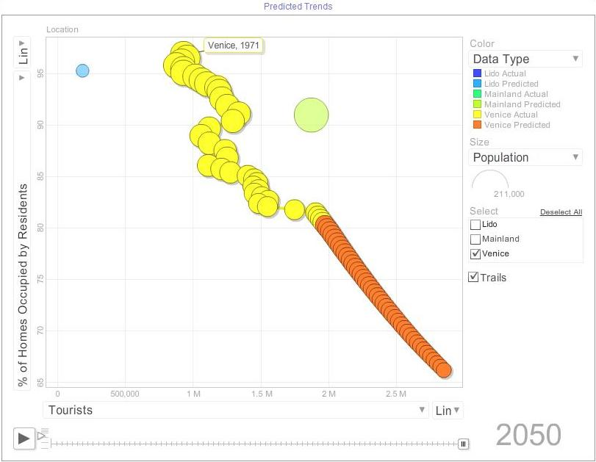come to pass.

# Bibliography

Aenlle, Conrad de. "AtHomeAbroad: Reading the fine print on an Italian retirement." *International Herald Tribune*, November 23, 2002: 1-2.

Boca, Daniela Del. "Italian Migration." 11 2003. http://ftp.iza.org/dp938.pdf (accessed 09 20, 2008).

Bourke, Paul. *Interpolation Methods.* December 1999. http://local.wasp.uwa.edu.au/~pbourke/miscellaneous/interpolation/ (accessed October 28, 2008).

Brugiavini, Agar. "Social Security and Retirement in Italy." http://ideas.repec.org/p/nbr/nberwo/6155.html (accessed October 1, 2008).

*Central Intelligence Agency.* October 2, 2008. https://www.cia.gov/library/publications/the-world-factbook/geos/it.html (accessed September 20, 2008).

*Citta' di Venezia.* http://www.comune.venezia.it (accessed September 15, 2008).

*Direzione programmazione e controllo.* http://www.comune.venezia.it/flex/cm/pages/ServeBLOB.php/L/IT/IDPagina/345. (accessed September 10, 2008).

*Economist.* www.economist.com/media/pdf/QUALITY_OF_LIFE.pdf (accessed September 14, 2008).

*EUROPA.* http://europa.eu/index_en.htm. (accessed September 15, 2008).

*EUROPA.* http://europa.eu/abc/keyfigures/qualityoflife/index_en.htm. (accessed September 27, 2008).

*Facts about Italy.* http://facts-about-italy.blogspot.com/2008/02/cost-of-living-in-italy.html. (accessed September 17, 2008).

Feldmann, Berthold. *Eurostat.* March 23, 2008. http://epp.eurostat.ec.europa.eu/cache/ITY_OFFPUB/KS-SF-08-082/EN/KS-SF-08-082-EN.PDF (accessed October 5, 2008).

*Free Dictionary .* http://www.thefreedictionary.com/quality+of+life (accessed September 28, 2008).

Greene, Ta Karra, Benjamin Isabella, Freddy Jervis, and Danielle Modeste. *Residential Comfort Level: Analysis of the Venetian Retail Sector .* Interactive Qualifying Project, Venice, Italy: WPI, E05.

"Human Population Growth." 09 23, 2007. http://users.rcn.com/jkimball.ma.ultranet/BiologyPages/P/Populations.html (accessed 09 28, 2008).

*Index Mundi.* http://indexmundi.com/world/ (accessed October 4, 2008).

*Istituto nazionale di statistica.* http://www.istat.it/english/databanks.html (accessed October 5, 2008).

"Italian Education and Schooling in Italy." *Anglo Info.* http://rome.angloinfo.com/countries/italy/schooling.asp (accessed 09 20, 2008).

"Italy Education." *Nations Encyclopedia.* http://www.nationsencyclopedia.com/Europe/Italy-EDUCATION.html (accessed 09 25, 2008).

"Italy's Divorce Rate." *Bio-Medicine.* http://www.bio-medicine.org/medicine-news/Italys-Divorce-Rate-Jumps-74-Percent-in-10-Years-22404-1/ (accessed 09 28, 2008).

"Italy's Way of Life." http://library.thinkquest.org/J0112187/italy_way_of_life.htm (accessed 09 29, 2008).

Martin, Jonathan, San Antonio Geoffery, Starbard Nathan, and Wibisono Herbert. *Assessment of the Non-Residential Housing Market in Venice Italy.* Interactive Qualifying Project, Venice, Italy: WPI, E01.

*Mathematica: Extrapolation.* http://documents.wolfram.com/mathematica/Built-inFunctions/AdvancedDocumentation/DifferentialEquations/NDSolve/ODEIntegrationMethods/ControllerMethods/Extrapolation.html (accessed October 28, 2008).

*Mercer.* www.imercer.com/uploads/common/pdfs/definingqualityofliving.pdf. (accessed September 8, 2008).

*Nation Master.* http://www.nationmaster.com/country/it-italy (accessed September 15, 2008).

Povoledo, Elisabetta. *Venetian transport leaves tourists high and dry.* January 21, 2008. http://www.iht.com/articles/2008/01/21/europe/venice.php (accessed December 7, 2008).

*Quality of Life Index.* http://www.internationalliving.com/Internal-Components/Further-Resources/quality-of-life08. (accessed September 19, 2008).

*The Human Life Span .* August 10, 2000. http://maxweber.hunter.cuny.edu/~bseegmil/psych150/lifestag.htm (accessed October 13, 2008).

*The Italian Educational System.* http://www.ilsegnalibro.com/educatio.html (accessed October 12, 2008).

*Urban Audit.* http://www.urbanaudit.org/ (accessed October 5, 2008).

"US Census Bureau." *US Census Bureau.* http://www.census.gov/ (accessed 09 15, 2008).

Venezia, Industria Artigianato E Agricoltura. *Prezzi Medi Dei Prodotti Petroliferi .* November 15, 2008. http://74.125.43.100/translate_c?hl=en&sl=it&tl=en&u=http://www.ve.camcom.it/prezzi_borsamerci/file/prezzi_prodotti_petroliferi_15_11_08.pdf&usg=ALkJrhgPj0UAFz0gp5FUBtNUH4zIY39RdA (accessed December 7, 2008).

*Venice in Peril - The British Committee for the Preservation of Venice.* http://www.veniceinperil.org (accessed September 15, 2008).

*Word Cloud.* www.wordle.net (accessed October 5, 2008).

*Writing Guides: Survey Research.* http://writing.colostate.edu/guides/research/survey/com3b1.cfm (accessed October 12, 2008).

1. Motion Chart
2. Assessment of Non Residential Housing IQP
3. *Citta' di Venezia.* http://www.comune.venezia.it (accessed September 15, 2008).
4. Venezia, Industria Artigianato E Agricoltura. *Prezzi Medi Dei Prodotti Petroliferi .* November 15, 2008.
5. Greene, Ta Karra, Benjamin Isabella, Freddy Jervis, and Danielle Modeste. *Residential Comfort Level: Analysis of the Venetian Retail Sector .* Interactive Qualifying Project, Venice, Italy: WPI, E05