

A Tourist Guide to a Unique and Enriched Experience of Venice

Submitted By:
Daniel Cianfrocco
Cordero Marrero
Lindsay Mullins
Danielle Volpe

Project Advisors:
Fabio Carrera
Paul Davis

Collaborators:
Dr. Donato Concato
Bruno Nogara
Laura Sabbadin
Professor Michele Tamma

Date: July 29, 2026
http://wikivenice.org/index.php/Venice-B08_IQP:_Visiting
ve08-visit@wpi.edu

Contents
Chapter 1: Introduction 5
Chapter 2: Background 8
Tourism 8
Tourism in Venice 9
Web 2.0 10
Profiling 11
Analyzing the Tourist 12
Criteria and Categories 15
Chapter 3: Methodology 17
Developing a system for profiling tourist preferences. 18
Determine efficient system for identifying what draws tourist to attractions 20
Creating the prototype of a socially driven website. 21
Support Donato Concato in developing a grant proposal for a web 2.0 22
Chapter 4: Bibliography 23
Appendix A: Annotated Bibliography 25
Crowdsourcing 25
E-Tourism 25
Profiling 25
Psychology and Behaviors of Tourists 27
Recommender Systems 27
Socially Driven Websites (Web 2.0) 28
Tourism 28
Tourists in Venice and their Effects on Cities 29

FIGURES
Figure 1: World Tourism Trends 5
Figure 2: Worldwide Export Earnings 9
Figure 3: The Viscous Cycle of Tourism 10
Figure 4: Tree of living things started from the bottom 15
Figure 5: Portion of the home page of YouTube account 16
Figure 6: Spatial boundary 17
Figure 7: Characterization of Tourists 19

Tables
Table 1: Economic features of Spain and Italy 8
Table 2: Categories of Tourists 20

Chapter 1: Introduction

Every year, 900 million tourists travel worldwide, each seeking their own unique experience as displayed in Error: Reference source not found (UNWTO World Tourism Barometer, 2008). Every tourist differs, having varied interests, desires, and motivations for travel. As the technology of transportation is advancing, faster and more efficient means of travel are more readily available. The Internet is also continuously expanding and improving. One can search for and book flights, hotels, and excursions with the click of a button, making this sometimes stressful process painless. Also, with the more recent development of social websites, one can view reviews of other’s tourist experiences to get a more personal account of what their trip may entail. These advances in technology may correlate with the rise in tourism as travel has now become a simple process.
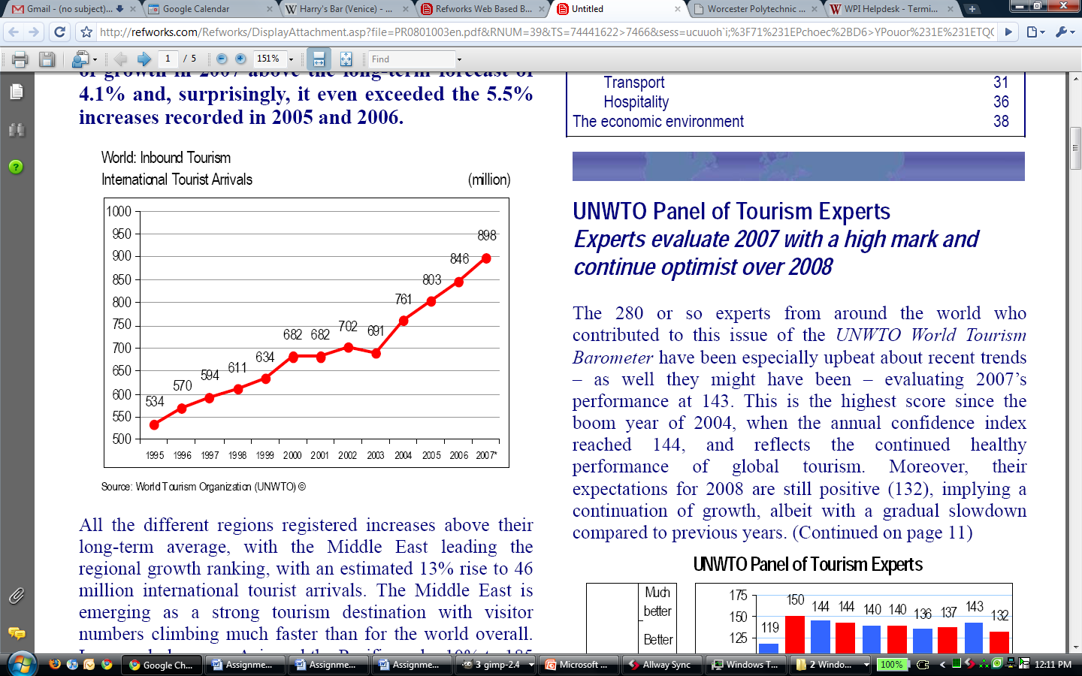
Figure 1: World Tourism Trends
Venice, the 28th most popular city destination of 2006, (Euromonitor International, 2007) draws in approximately 15 million tourists per year (Bahlatzis, 2007). As tourism continues to grow in Venice, technology is also making advancements. Websites, specifically web 2.0 sites such as TripAdvisor, are used frequently when planning vacations. Approximately % of Americans travel to Venice (source) and 66% of American users claim that e-tourism is a better resource for travel than travel agents(Carton, 2007). The advancements in technology will help tourists to benefit greatly from vacations to Venice and allow them to have a positive experience.
The large number of tourists that travel through Venice can provide a wealth of information through crowdsourcing. Crowdsourcing is a neologism that was coined by Wired Magazine’s Jeff Howe. By collecting input from a multitude of users, crowdsourcing replaces tasks that were once performed by paid specialist. If enough information is generated, amid the majority of useless information is a small set of valuable information (Howe, 2006). The internet has created a large set of information which is necessary for this system to work. For example, 64% of teenagers between the ages of 12 and 17 participate in online content creating activities (Lenhart, 2007). This method of gathering large amounts of information has been successfully applied to tourism through websites like TripAdvisor (Ulrike, 2007). TripAdvisor provides mostly user-generated content, and although user-generated content is not always valuable, successful rating systems are used to filter the good content from the bad. In addition to crowdsourcing, online tourism profiling has proven to be very effective in matching tourists to the places and activities that interest them, offering personalized results similar to a travel agent (Rashid, Al Mamunur 2002). Profiling is a process of gathering information about a user, either assertively or passively, and using it to build an assumption of their likes and interests. The idea of profiling started with other markets such as the music industry and online shopping. Websites like Pandora.com and Amazon.com have pioneered successful systems for profiling users, and have laid the foundation for profiling in many other ways. Crowdsourcing and profiling allow for a beneficial user experience.
Currently, there are a number of useful tools and research that aid tourists in planning trips, unfortunately, none have been applied to the city of Venice. Also, no efficient method of extracting specific preferences from tourists to create profiles exists. Because these tools are currently unavailable to tourists of Venice, they must rely on less efficient means to gather information about their vacations.

The ultimate goal of our project is to enrich the tourist experience in Venice by creating a prototype “web 2.0” site with customized features generated by user preferences. This website will be socially driven and will provide tourists with insight on attractions in Venice based on the collective experiences of past visitors to Venice. The website will be continuously updated with input from user experiences to offer the most recent information. The site will also recommend the quickest path to destinations with leisurely diversions along the way depending of user preference or time available for travel. A combination of these efforts will contribute to the enhancement of the tourist experience in Venice. In completion of this project we will have laid the grounds for future IQP and or MQP projects that will create the website and provide tourists of Venice with a unique visiting experience.

Chapter 2: Background

Tourism
Tourism is becoming one of the fasted growing industries, as international tourism arrivals are increasing at a rate of 6.5% every year and the income generated from the industry has grown at an annual rate of 11.2%. (UNWTO World Tourism Barometer, 2008). For many countries, tourism is the main source of income as displayed in Table 1. This Table shows the increase in tourism from 1960 to 2000 for two specific countries, Spain and Italy(Cortes-Jimenez, 2006). **conclusion about table
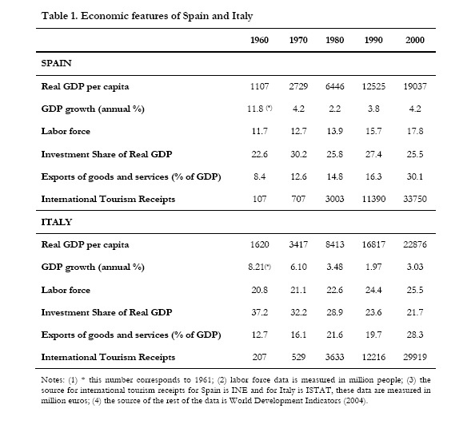
Table 1: Economic features of Spain and Italy

The growth in tourism can be attributed to a number of factors. People are taking longer holidays and therefore are more motivated to travel to farther around the world. Also, as technology is expanding, fast and efficient means of travel are becoming more readily available. People are beginning to take advantage of these new modes of transportation and are traveling more often. The internet provides a wealth of knowledge on travel which allows one to book flights, cruises, or hotels quickly and easily. The internet and TV provide a home for advertising of different destinations. As more knowledge is available about these destinations, people are more interested in exploring them and as more people travel, tourism is flourishing. (The rise of tourism, 2008)

Travel provides a chance to get away from the stresses of everyday life and a chance to spend time with friends and family. These combinations of factors have contributed to the huge influx of tourism over the past few years. Figure 2 shows how tourism is now the leading export.

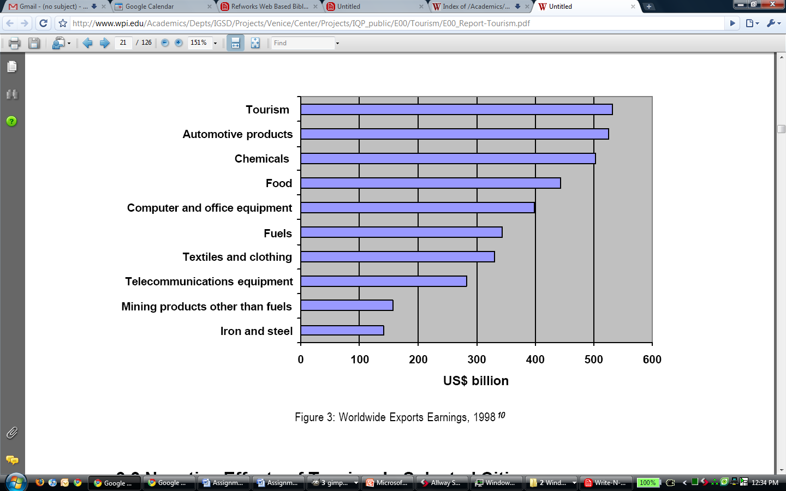
Figure 2: Worldwide Export Earnings

Tourism in Venice
The city of Venice is a popular tourist attraction, hosting more than 15 million tourists per year (Bahlatzis, 2007). Venice is a small city experiencing “The Vicious Cycle of Tourism Development (Russo, 2000).” Figure 3 displays this “Vicious Cycle”. Venice like other historical tourist attractions is becoming increasingly popular. More tourists are traveling as excursionists or “day trippers” to avoid the cost of renting a hotel for the night. In fact, over 80% of the tourists visitng Venice are excursionists (Bahlatzis, 2007). These excursionists add to the congestion of the city because they only have enough time to visit the major “hot spots” of the city such as St. Mark’s Square, therefore causing these hot spots to become overcrowded. Since many excursionists are not interested in spending excessive amounts of money for high quality, selective products, local sellers reduce the quality of their items and sell for lower prices, which may benefit the excursionists, but quickly becomes a detriment to the economy.
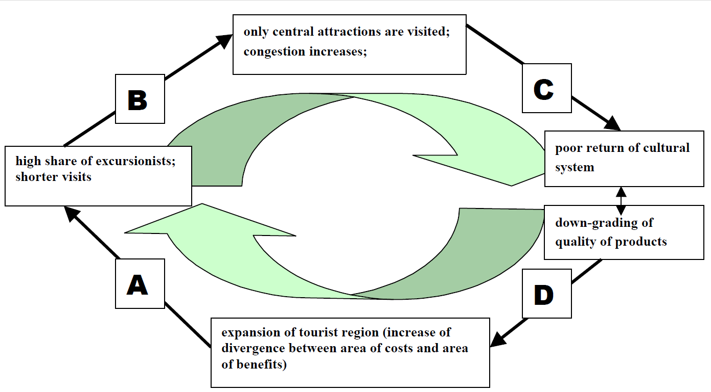
Figure 3: The Viscous Cycle of Tourism

Although, tourism constitutes 70% of the city’s income, Venice spends €250 million per year repairing the damage caused by these visitors (Bahlatzis, 2007). Venice experiences this cycle of tourism especially during its peak seasons of April through October. During July and August, the two most popular tourist months, most hotels are filled to capacity, many restaurants are closed, and all popular attractions are congested (Infohub, 2008). The celebration of Carnevale, besides Christmas, is the most popular time to visit the city. Carnevale is a celebration in February before the season of lent where parades, balls, and other forms of entertainment encompass the city (Infohub, 2008). Some believe Carnevale has transformed into a celebration specifically for tourists. Tourism essentially controls the city of Venice and the congestion tourism creates can be less enjoyable for both tourists and locals therefore it is important to enhance overall tourist experience in Venice through the use of new technologies such as Web 2.0.

Web 2.0

The most important aspect of a web 2.0 site is its users; Web 2.0 is strictly maintained by the input and feedback from everyday people (Wesch, 2008). It’s a socially driven network of collaboration, which allows the website to ultimately run on its own (Wesch, 2008). Websites such as “YouTube,” “Facebook,” “Amazon.com,” and “Pandora” are a few of the popular web 2.0 sites in use today which through continued feedback from users, provide users with suggestions of either videos, friends, products, or music based on the users past preferences. For example, “Pandora” will generate a list of specific songs the user may enjoy based on the users previous song selections. Therefore, web 2.0 is specifically tailored to the user through feedback from the user.
Web 2.0 has already proven to be an effective method for catering to the needs of the user, but it is necessary to determine the effectiveness of web 2.0 sites geared towards tourism to determine the usefulness of our project. Dr. Ulrike Gretzel in coordination with Kyung Hyan Yoo and Melanie Purifoy, conducted numerous studies of 7,000 Trip Advisor users on the effectiveness of the popular web 2.0 tourist site. “Trip Advisor” provides information on restaurants, hotels, flights, and attractions at almost any location. To determine the effectiveness of the site, identifying the type of user is a critical step. The research conducted on this website showed that the most frequent visitors, approximately 64% of the users, to the site were females between the ages of 35 and 64 who have children living in their homes (Ulrike, 2007). These women prefer to thoroughly plan their vacations and do not enjoy spontaneous activities. Although, the majority of the users were women, the study also showed that 96% of the 7,000 people used the internet for trip planning purposes (Ulrike, 2007). However, probably one of the most important finds of this study showed that 90% of the users read other users comments (Ulrike, 2007). This result is important in displaying the effectiveness of social websites. A large population of the users relies on each other’s feedback to determine the best location and destination for their own trip.

Profiling
Along with the use of Web 2.0 to enhance the tourist experience, it is important to understand the aspect of profiling tourists to allow for a unique customized trip. As computer technology has developed, internet recommender systems have also developed in order to recommend items or ideas to the user such as music, movies, shopping items, news or images. These systems use certain methods to extract preferences from the user. They then use the knowledge obtained from the preferences gathered to suggest further information for the user.

The three main categories for profiling are content-based filtering, collaborative filtering, or a hybrid of the two. Content-based systems suggest items or ideas that relate to what the user has purchased or viewed previously. These systems focus on keywords relating to the item or topic. For example, if one searched for “astronomy”, the system would not only generate information with astronomy in the description, but also possibly, “constellations”, “The Big Dipper” and “moon”. In addition,these systems rank their suggestions so, for example, works with a higher frequency of the keyword “astronomy” would be given greater importance than ones with less frequency. (Adomavicius,G., 2005)

One popular example of content-based filtering is Pandora.com. Pandora is a music website that creates playlists tailored to the user’s preferences. At Pandora.com, the user types a song or artist into a search and Pandora generates a list of similar songs based on certain attributes. To make this site possible, employees have broken down millions of songs and ranked them according to about 400 different categories, such as “male or female lead singer” or “acoustic or instrumental”. With such detailed information for each song, it is easy to match songs and artists of similar styles and to recommend songs that the user is sure to enjoy. (Pandora: Radio from the Music Genome Project, 2008) This application of content-based filtering has proved very successful and is utilized by music fans every day.

Collaborative filtering systems suggest items or ideas that other users with similar preferences have chosen previously. Within this system, there are two main methods used, the “memory-based” method and the “model-based” method. In the memory-based method, the system develops a “neighborhood” of users who have ranked items similarly or bought similar items. When a user searches for a product, the system will generate a list of suggestions based on the purchases of their “neighbor”. Model-based filtering creates a “model” of user ratings utilizing probability to generate recommendations.. (Sarwar, 2001)

Amazon.com provides an example of collaborative filtering. Each time a user searches a product on Amazon, the site generates a product description, list of user reviews, and a section labeled “Customers who bought this item also bought”. Under this section, the site recommends a list of items that others have bought, assuming that since two people have searched for the same item, they may have similar tastes. It is a seemingly simple process; however, it is very effective in recommending items based on users preferences. (Amazon, 2008)

Hybrid systems can combine content-based filtering and collaborative filtering in several effective ways. Adomavicius and Tuzhilin list 4 ways to merge the two systems. “1. Implementing collaborative and content-based methods separately and combining their predictions. 2. Incorporating some content-based characteristics into a collaborative approach. 3. Incorporating some collaborative characteristics into a content-based approach. 4. Constructing a general unifying model that incorporates both content-based and collaborative characteristics.” By combining the most effective aspects of each system, hybrids create very efficient recommender systems. (Adomavicius,G., 2005)

Analyzing the Tourist

In order to accurately profile tourists, it is necessary to understand the tourists themselves. No two tourists are alike and their differences in preferences and attitudes each contribute to different tourist experiences. “Researchers have proposed that relationships exist between individual psychological characteristics, consumer behaviors, demographic characteristics, and the types of tourism experiences they desire” (Hsu, 2002). Therefore, one must learn the psychology of tourists to fully understand how tourism functions.

There are two main groups of tourists, excursionist and residential. This categorization is purely based on type of travel, not tourist behavior. Excursionist tourists are those who do not stay overnight (Pressing Issues: A Venetian Socioeconomic Overview, 2007). These tourists may not spend the night because of the high cost of hotels and Bed & Breakfasts or often because these hotels have no vacancies. Excursionist tourism is becoming more popular as people want to visit many different destinations during their vacation, rather than just one (An Assessment of the State of Tourism in Venice, 2000).

75% of tourists are excursionist tourists while the remaining 25% can be categorized as residential tourists. Residential tourists spend at least one night at their destination. They may stay at a hotel, B&B, or rent an apartment for an extended period of time (Pressing Issues: A Venetian Socioeconomic Overview, 2007). These two types of tourists may each be seeking two different types of experiences.

Tourism is a process of supply and demand. The demand is “a function of characteristics of the individual tourist such as their income, age, motivations and psychological make-up, which will variously affect their propensity to travel for pleasure, their ability to travel and their choice of destinations (p. 8, Ross, Glenn F.).” The supply is “a function of characteristics and attributes of the tourism destinations, their attractions, prices and the effectiveness of the marketing of the destination (p. 8, Ross, Glenn F.).” The demand is influenced by the locals of the destination and their attitudes towards the tourists. As in any model, demand affects the supply. The impressive characteristics of tourist destinations and the marketing of these destinations will encourage more tourists to travel and increase the supply. Supply also affects the demand as the popularity of a place may allow for better marketing and maintenance of an area, bringing more people to the area (p. 9, Ross, Glenn F.).

Mannell and Iso-Ahola have proposed questions like “What factors lead people to describe an activity or a set of activities as authentic tourism or touristic experiences? Are these personal definitions similar to those of tourist operators or researchers? Are authentic touristic experiences leisure experiences? Are there other meaningful dimensions by which tourists label and define their experiences? (p. 13, Ross, Glenn F.)” Mannell and Iso-Ahola concluded that people take vacations to escape from stress and routine (p. 13, Ross, Glenn F.). Similarly, Gray came up with two main motivations for tourist travel. Wanderlust, which is “leave things familiar and to go and see different places,”, or “rest and relaxation.” Sunlust is the desire for better amenities,” or “motivated by the desire to learn (p. 22, Ross, Glenn F.).” Tourists can be divided into these two categories when determining their motivation for travel.

Plog has a personality theory of tourism stating that travelers are either allocentric or psychocentric. Allocentric travelers “prefer exotic destinations, unstructured vacations rather than packaged tours, and more involvement with local cultures.” Psychocentric travelers “prefer familiar destinations, packaged tours, and touristy areas.” He found that there are also high-energy travelers and low-energy travelers. High-energy travelers prefer lots of activity while low-energy travelers do not like lots of activity (p. 32, Ross, Glenn F.). This is yet another way that the tourists are categorized.

Psychographics have become a popular method in determining the psychology of customers as well as their behaviors and styles of living. Psychographs have been applied to tourists to discover just that. It analyzes the “individual’s activities, interests, and opinions (Hsu, 2002).”

Plog lists eight categories by which to psychographically define tourists. These eight categories are “venturesomeness, pleasure-seeking, impulsivity, self-confidence, planfulness, masculinity, intellectualism, and people orientation (p. 34, Ross, Glenn F.).” Most tourists fall into one of these eight basic categories and this characterization can be used to further profile the traveler.

Every tourist falls into these categories and by breaking the tourists into each of Gray’s and Plog’s categories, one can get a more accurate interpretation of their psychology. Each combination of categories indicates a different type of tourist. By analyzing each category and their possible combinations, one better understands these different, unique types of tourists.

The tourist’s attitude is a great aspect of psychology to explore. Um and Crompton thought that the image and “attitude” of a destination were the two main factors that drew tourists toward these destinations. (p. 46 Ross, Glenn F.) **look more into attitude?

Tourists don’t have the best reputation with the locals in their destinations. They believe tourists are “fatuous, lazy, and plain ‘dumb’ (McCabe, Scott, 2005)”. With such a negative attitude directed towards tourists, tourists try hard to fit in with the locals. (McCabe, Scott, 2005 ).”

Criteria and Categories
In order to better understand certain items it is best to compare them to other items in a similar field. A categorization process is often created to analyze the criteria of similar items. This process allows for the determination of differences between items and distinguishes the uniqueness of particular items.
One method of categorization is taxonomy. Taxonomy is the science of classification where items are arranged in a hierarchy. In this hierarchy there is a parent-child relationship where items are arranged in sub-types and super-types (ex; a shirt would be a sub-type for clothing) where Super-types are vague and sub-types are more specific. The most commonly known taxonomy tree is for living things. The base super-type for this tree is “living things” which branches into subtypes of “plants” and “animals.” As the tree progesses items become more specific as displayed in Figure 4.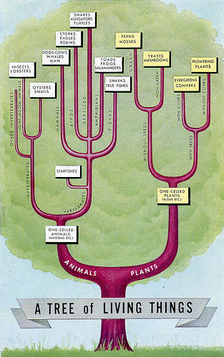
Figure 4: Tree of living things started from the bottom
Another type of categorization is folksonomy. Folksonomy is the process of collecting input from various users through “tagging” items. Items are then categorized based on these tags. They are ranked based on number of times views received or by the ratings received. Folksonomies are beneficial because they are purely based on the users opinions which allows the categorization to be determined by the user and customized to the users specific preferences. Youtube.com is an example of a folksonomy where multiple users upload videos giving them “tags.” Other users then view these videos and give them ratings, tags, and comments. The videos are then categorized based on these various criteria (Figure 5). This site automatically updates itself and categorizes the videos based on the constant input from various users as displayed in figure 5.
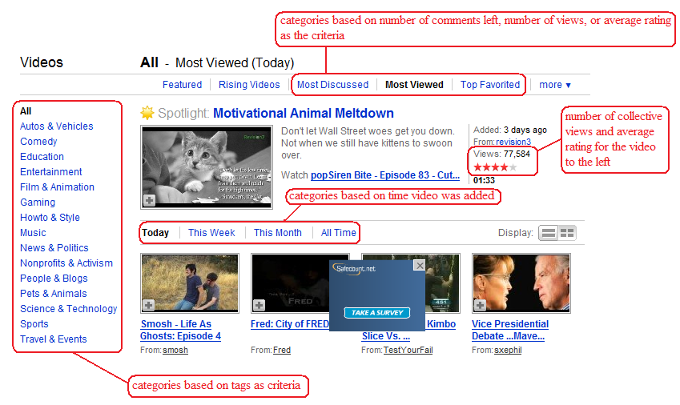
Figure 5: Portion of the home page of YouTube account

Chapter 3: Methodology
The ultimate goal of this project is to enrich the tourist experience in Venice by creating a prototype “web 2.0” site that will provide numerous features based on user preferences and reviews. This website will eventually contain wikis of our personal experiences in Venice as well as the experiences of other tourists. The socially driven website will remain up to date as new users continue to post comments about their experiences. Our web 2.0 prototype will provide the grounds and background information needed for the launch of a recommender system that will automatically generate personal itineraries for tourists of Venice and suggest specific sites to visit through podcasts. The website will not limit itself to suggesting only high profile attractions, it will also suggest lesser known activities and areas based on user preferences that are guaranteed to please the tourist. Our project will allow future project groups to create a fully functional web 2.0 site that will offer tourists a new and unique experience not only for tourists Venice but for tourists all over the world.
However, to accomplish our ultimate goal we must first:
- Develop a system to profile tourists’ preferences.
- Determine a system to identify what draws tourists to attractions.
- Create the prototype of a socially driven tourism website.
- Support Dr. Concato in his grant proposal for the website.

Our project aims to assist the Venetian tourist by providing them with the most relevant and complete information applied to their specific interests. In order to accommodate all tourist interests, our spatial boundaries should encompass the entire city of Venice.
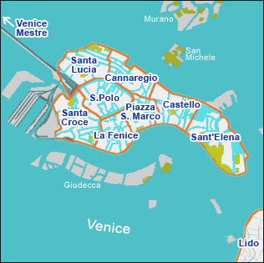
Figure 6: Spatial boundary
The focus of our research will be the tourists of Venice and their interests as well as the use and effectiveness of social websites. We will also study the development of and mechanics behind profiling and recommender systems. This information will be used to design our own web 2.0 prototype that will incorporate the use of recommender systems through podcasts and will provide tours and itineraries specifically tailored to the tourists.

Because we will be working in Venice during the fall, our profiling system will focus on tourism in the fall season. We will be conducting “field work” in half hour intervals in the early morning, early afternoon, and late afternoon. This will give us insight on the activity and interests of tourists at different times of day. The data collected will be applied to refining our information gathering process and making a well-rounded profiling system.

Our project focuses on the tourists of Venice. To gather the basic understanding of the interests and desires of the average tourist, we will conduct research on tourists’ behaviors.

We will be creating a prototype of a web 2.0 site. Our project will be the blueprint used to create a fully functional web 2.0 site equipped with a recommender system the automatically generates itineraries for tourists.

Developing a system for profiling tourist preferences.
The creation of a prototyping system is deeply rooted in the fields of computer science, statistics, and psychology. In order to fully develop a profiling system, a comprehensive understanding of all of these topics is required, and is beyond the scope of our project. Instead, we will provide the high-level methods for obtaining profile information, the guidelines of profiling, and the incentives for the users.

To begin the profiling process we must first categorize the tourists. We will use Gray and Plog’s methods of categorizing tourists to generate a set of 28 specific types of tourists. These 28 specific types of tourists were identified through an organizational tree of tourist characteristics. Based on Gray and Plog’s research, the researchers divided tourists between the “wanderlust” those who vacation for relaxation and “sunlust” those who vacation to learn something new. These two categories are then dvided into two more: allocentric, those who seek the less visited areas for adventure and psychocentric, those who prefer the “touristy areas.” These two categories are divided into 8 more categories of venturesomeness, pleasure-seeking, impulsivity, self-confidence, planfulness, masculinity, intellectualism, and people orientation. From these categories our team generated a tree which was used to create a database for all possible combinations of tourists as displayed in Figure 7: Characterization of TouristsFigure 7.
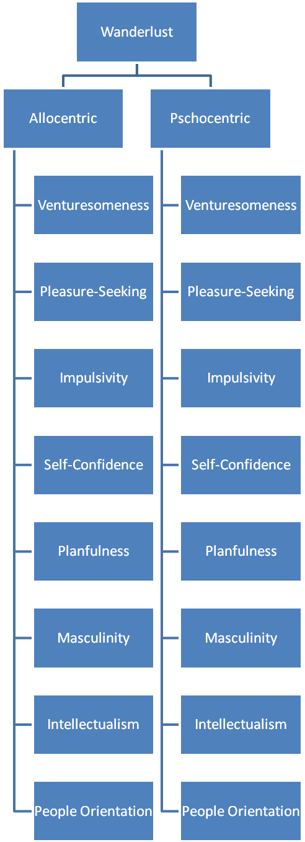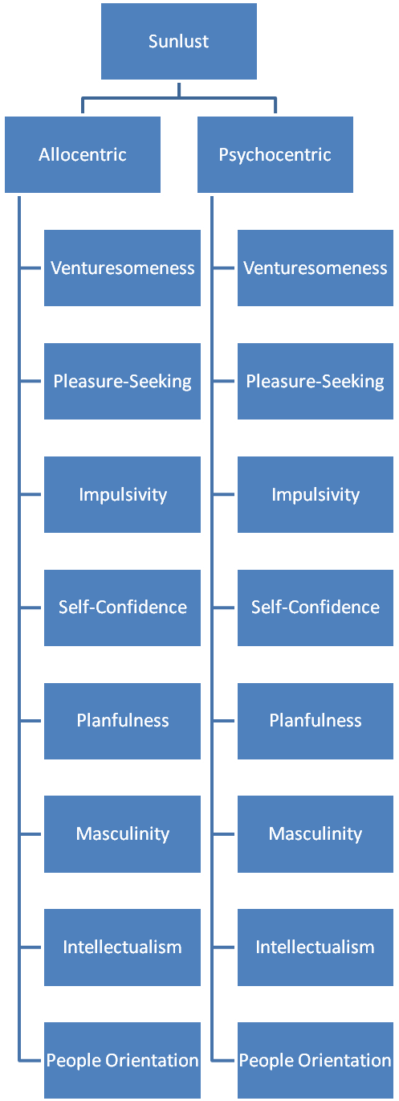
Figure 7: Characterization of Tourists
From these categorization trees, all possible combinations were created generating a list of 28 different types of tourists as shown in Table 2.
Wanderlust |  | Wanderlust |  | Sunlust |  | Sunlust
Allocentric |  | Psychocentric |  | Allocentric |  | Psychocentric
Pleasure-Seeking |  | Pleasure-Seeking |  | Pleasure-Seeking |  | Pleasure-Seeking
Wanderlust |  | Wanderlust |  | Sunlust |  | Sunlust
Allocentric |  | Psychocentric |  | Allocentric |  | Psychocentric
Impulsivity |  | Impulsivity |  | Impulsivity |  | Impulsivity
Wanderlust |  | Wanderlust |  | Sunlust |  | Sunlust
Allocentric |  | Psychocentric |  | Allocentric |  | Psychocentric
Self-Confidence |  | Self-Confidence |  | Self-Confidence |  | Self-Confidence
Wanderlust |  | Wanderlust |  | Sunlust |  | Sunlust
Allocentric |  | Psychocentric |  | Allocentric |  | Psychocentric
Planfulness |  | Planfulness |  | Planfulness |  | Planfulness
Wanderlust |  | Wanderlust |  | Sunlust |  | Sunlust
Allocentric |  | Psychocentric |  | Allocentric |  | Psychocentric
Masculinity |  | Masculinity |  | Masculinity |  | Masculinity
Wanderlust |  | Wanderlust |  | Sunlust |  | Sunlust
Allocentric |  | Psychocentric |  | Allocentric |  | Psychocentric
Intellectualism |  | Intellectualism |  | Intellectualism |  | Intellectualism
Wanderlust |  | Wanderlust |  | Sunlust |  | Sunlust
Allocentric |  | Psychocentric |  | Allocentric |  | Psychocentric
People Orientation |  | People Orientation |  | People Orientation |  | People Orientation

Table 2: Categories of Tourists
Each of the 28 tourists types will be thouroughly anazlyzed to determine the specific interests of each type of tourist and to then use the results to match tourists with specific attractions.

After analysis of the tourist, methods for gathering profiling information must be determined. Users do not want to be bothered by long surveys, constant questions, or any other process that takes up time. As a result, the information needs to be mined indirectly from the actions and behaviors of the user.

In the typical social website, content is created, reviewed, and downloaded by a database of registered users. Because the users are logged in, their behaviors are easily tracked and recorded. This creates a huge wealth of information that will need to be analyzed. We will determine the most useful pieces of data that can be generated and how they can be used.

In the event that a user would like to use website features that require a comprehensive profile, a quick method of profiling will need to be created. This will need to be a system of questions or comparisons that are strategically decided to generate a new profile in the least number of steps possible. We will design a system that will consist of a set of questions that will categorize tourists into a generic set of tourist preferences.

Determine efficient system for identifying what draws tourist to attractions
In order to create efficient profiles for tourists as well as recommend attractions to them, we must know what tourists demand out of different attractions as well as what these attractions supply. We will be developing a system for identifying this supply and demand relationship for tourists and attractions in Venice. We will be studying the mentality of tourists to see why they travel in comparison to where they go. Once in Venice we will conduct research on the tourists to see what they bring to a place in comparison to where they are going (ex; bringing a camera to a location implies a site seeing purpose). We will also pay close attention to the tourist’s behaviors toward the location that they visit.
We will take the analysis of tourist behaviors as well as the input from tourist interviews to create a folksonomy for these attractions. Tourists can put tags and reviews on sites they visited based on their experience in these places. Attractions can then be clustered based on these tags and analyzed based on their reviews. Because of the fact that folksonomies are dependent on the collective input of various tourists the categorization of these attractions will change over time and become better suited for those who are looking for attractions to visit.

Creating the prototype of a socially driven website.
The end goal of this and other projects is to help Dr. Donato Concato in writing a grant proposal for the entire social tourism website. One way we are going to support Dr. Concato is by creating a prototype website that can be used in presentations and documents during the proposal process. We will be studying existing works, both publications and websites. An effective mockup is going to need to consider every aspect of web design.

Designing a website begins by outlining the generic layout of the website. Modern websites only consist of a small handful of layouts like the homepage, search results, and a content page. Once those layouts are created, every other page on the website will be generated inside these layouts with minimal amounts of coding.

The layouts will need to be easy for users to navigate; this is usually achieved with the familiar header and left-hand navigation column. Usually a site navigation tree will be generated. The navigation tree will start with large sections like the departments in a store, and it will narrow the deeper you get, like the labels on isles. The tree is used to create the small series of links commonly at the top of a webpage, for example: Home>History>Venice>Doges>Ludovico Manin. These can be referred to as a “trail of breadcrumbs” a user can use to figure out where they are and how to get back in the future (Krug, 2006).

Once a layout is decided, it is then time to decide on the style of the website. This is when color themes, fonts, logos, buttons, and graphics are applied to the layout to make it look professional and memorable. Poor themes and styles will cause the users to question the validity of the website, and an unoriginal design will cause the site to be forgotten.

At this point it will be necessary to evaluate the web design. A focus group will be created, and the goal will be twofold: to evaluate the effectiveness of the design, and to observe user interaction behaviors. The evaluation of the effectiveness of the website will be used to improve the design and flow of the website. Improving the user’s experience of the website will keep users on the website longer and increase the chances the users will return. Observing the users’ behaviors will be an important step in the design of the user profiling system. Before this point, most of the profiling system was created through speculation. Observing the users will provide invaluable feedback into the accuracy of the profiling system.

Support Donato Concato in developing a grant proposal for a web 2.0
Donato Concato is putting together a grant proposal for a tourist web 2.0 site that automatically creates itineraries based on user preferences. Our primary objective is to support him in developing this grant proposal. In order to do this we will have to successfully complete the previous objectives. We will be putting together our prototype of the web 2.0 with our data on profiling tourists and attractions as a blueprint that Dr. Concato will be able to use for his grant proposal. Because the idea for the web 2.0 was originally his, he will be able to assist us with advice on tourist interviews as well as ideas for the web 2.0 mock-up so that our work best suites his needs.

Chapter 4: Bibliography
Alexander, B. (2006). Web 2.0: A new wave of innovation for teaching and learning.41(2), 32-44.
Bahlatzis, Jonathan, D'Angelo Sophia, Hamlet, Nina and Shomorony, Ilan. (2008). Venice Wiki Book Everything you ever Wanted to know about Venice. Retrieved September 17, 2008, from http://venice1point0.wikidot.com/venice1-0
Barcelona field studies centre. (2008). Retrieved 9/27, 2008, from http://geographyfieldwork.com/
Banasree, Dey and Sarma, M.K. (2006). Tourist typologies and segmentation variables with regard to ecotourists.VII, 9/27/08.
Berka, T., & Plößnig, M. (2004). Designing recommender systems for tourism. Salzburg, Austria: Salsburg Research.
Bremner, C. (2007). Top 150 city destinations: London leads the way. Retrieved 20/Sept., 2008, from http://www.euromonitor.com/Top_150_City_Destinations_London_Leads_the_Way
Caruso, R. W., Cryan, M. P., Holton, A. E., Pancheri, F. Q., & Schady, M. (2000). AN ASSESSMENT OF THE STATE OF TOURISM IN VENICE. Unpublished manuscript.
Hughes, J. and Hanek, H. (2003). System and Method for Intelligently Determining User Preferences and Responding Thereto
Krug, S. (2006). In Whitehouse K. (Ed.), Don't make me think (Second ed.). Berkeley, CA: New Riders.
Lenhart, A., Madden, M., Macgill, A. R., & Smith, A. (2007). Teens and social media. Washington, DC: PEW Internet & American Life Project.
McCabe, S. (2005). Who is a tourist? A Critical Review., 85-85-106.
Rashid, A. M., Albert, I., Cosley, D., Lam, S. K., Mcnee, S. M., Konstan, J. A., et al. (2002). Getting to know you: Learning new user preferences in recommender systems. Paper presented at the 127-134. (World Tourism Statistics Exceed Expectations in 2007, 2008)
Raveh A and Shoval, N. (2004). Categorization of Tourist Attractions and the Modeling of Tourist Cities: Based on the Co-Plot Method of Multivariate Analysis. Tourism Management,
Riganti, Patrizia and Strielkowski, Wadim, Jing Wang, “Cultural Tourism and E-services; Using in Depth Interviews to Assess Potential Consumers’ Preferences”, 47th Congress of the European Regional Science Association, 2007
Russo, A. P. (2002). The "vicious circle" of tourism development in heritage cities. Science Direct, 29(1), 165-165-182.
Steinbauer, A., & Werthner, H. (2007). Consumer behaviour in e-tourism. Information and communication technologies in tourism 2007 (pp. 65-65-76) Springer Vienna.
Venice Italy Guides.it A sightseeing Revolution. Retrieved 9/27http://www.italyguides.it/us/venice_italy/download_audio_book_guides/free_ipod_mp3/venice_ipodguides.htm
World tourism statistics exceed expectations in 2007.(2008) Retrieved 9/28 World http://www.asiatraveltips.com/news08/301-TourismStatistics.shtml

Appendix A: Annotated Bibliography

Crowdsourcing
Arbors, J., J.C. Ramos, J.L. Hervais. (2008). New Learning Network Paradigms: Communities of Objectives, Crowdsourcing, Wikis and Open Source. ScienceDirect, , 194-194-203.

This article discusses the motivations for and consequences of “collaboration paradigms”. It discusses how this new idea was developed and their advantages and disadvantages. It also discusses different examples of these “collaboration paradigms” such as wikis or RSS blogs.

Brabham, D. C. (2008). Crowdsourcing as a Model for Problem Solving: An Introduction and Cases. The International Journal of Research into New Media Technologies, 76-76-92.

This article discusses the idea of crowdsourcing as a “model for problem solving. It also gives several examples of how crowdsourcing has been used as this model. It explores the idea that crowds are often more efficient at problem solving than a concentrated team of individuals

E-Tourism
Riganti, Patrizia and Strielkowski, Wadim, Jing Wang, “Cultural Tourism and E-services; using in depth interviews to assess potential consumers’ preferences”, 47th Congress of the European Regional Science Association, 2007

This article describes the use of in-depth interviews to analyze tourists for e-services to improve access to cultural heritage in Amsterdam, Leipzig, and Genoa.

Sigala, M., “Reviewing the Profile and Behavior of Internet Users Research Directions and Opportunities in Tourism and Hospitality”, Journal of Travel & Tourism Marketing, 2/15/2005

This article creates a perspective for analyzing online tourists by integrating several aspects of e-business such as the individual and the societal. The article also aims to discuss future research opportunities in the behavior of online tourists.
Steinbauer, Annette and Werthner, Hannes “Consumer Behaviour in E-Tourism” Science Direct, 2007
This journal is very useful because it discusses many tested studies that focus on the use of the internet by tourists for travel. Since we are trying to design a profiling website that will focus on the main needs of the tourist, this website will help determine the factors tourists use to influence their travel decisions.

Profiling
Adomavicius, G., & Tuzhilin, A. (2005). Toward the next generation of recommender systems: A survey of the state-of-the-art and possible extensions

This site gives an introduction to recommender systems. It provides a good explanation of each type of system and introduces the algorithms that they utilize. It also explains the pros and cons of each system and gives some examples of current sites that use these methods.

Amazon. (2008). Retrieved 9/30, 2008, from www.amazon.com

This website uses the collaborative filtering method of recommender systems. It is a practical example of this method.

Gretzel, Ulrike, Hyan, Kyung Yoo, & Purifoy Melanie. (2007). Online Travel Review Study: Role & Impact of Online Travel Reviews

This was a study done in collaboration with the leading example of tourist profiling online, Tripadvisor.com. The study was performed to examine the role and impact of travel reviews, to identify factors which influence perceived credibility, identifying motivations for posting online, and studying the demographics of frequent online travel reviewers.

Hughes, J. and Hanek, H., “System and Method for Intelligently Determining User Preferences and Responding Thereto”, US Patent App. 10/444719, 2003

This article is the description of claims for an inventions that provides the tool by which a though can be entered, interpreted, processed, presented back to the user, stored, and updated. In this article are a multitude of claims and diagrams that explain what the invention is capable of and how it works in terms of flow charts.

Pandora: Radio from the music genome project. (2008). Retrieved 9/30, 2008, from
www.pandora.com

Pandora utilizes the content-based filtering method. It’s a practical application of this method. Also, there is a short “About Pandora” section on the site that describes some of the methods behind the site.

Rashid, A. M., Albert, I., Cosley, D., Lam, S. K., Mcnee, S. M., Konstan, J. A., et al. (2002). Getting to Know you: Learning New User Preferences in Recommender Systems.

This is a very comprehensive paper explaining many different methodologies of profiling new users. They explore the most effective methods for profiling including how to tailor the questions so that redundancies are minimized. It also includes the results when the research was applied to a “live” study of over 300 participants.

Sarwar, Badrul, George Karypis, Joseph Konstan, and John Riedl. (2001). Item-based
collaborative filtering recommendation algorithms

This article focuses on the “collaborative filtering” method of recommender systems. It
provides a more in depth explanation of this method and its application.

Psychology and Behaviors of Tourists
Banasree, Dey and Sarma, M.K. (2006). Tourist typologies and segmentation variables with regard to ecotourists.VII, 9/27/08
This website is useful because it discusses the different tourist types. We will need to analyze tourists to create an effective profiling system, so therefore this article will be a useful resource.
Barcelona field studies centre. (2008). Retrieved 9/27, 2008, from http://geographyfieldwork.com/TourismClassification.htm
This site is useful because it classifies tourists in many different categories. These categorizations will be used when we try to profile tourists.
Ross, G. F. (1998). The psychology of tourism. Melbourne: Hospitality Press.

This book explores the psychology of tourists. It looks into the attitudes and behaviors of tourists to
discover their motivations for travel, and desires to participate in certain tourist activities. It draws from
several different tourist studies to explore deeply into the minds of tourists.

Hsu, Cathy H. C., Soo K. Kang and Kara Wolfe. (2002). Psychographic and demographic
profiles of niche market leisure travelers. Journal of Hospitality and Tourism Research, 26

This article assesses the use of psychographics in profiling tourists. It explains the psychographic method and how it was used to profile the tourists traveling to different “niche” destinations.

McCabe, S. (2005). Who is a tourist? A critical review., 85-85-106.
This article discusses the different types or “typologies” of tourists. This information will be useful to design an effective tourists profiling system.

Recommender Systems
Berka, T., & Plößnig, M. (2004). Designing Recommender Systems for Tourism. Salzburg Research.

This paper is one of the most useful sources on our list. It is an explanation of how to design a recommender system for tourists, written for non-technical people. It covers the types of filtering, how to choose one, and how to design your system architecture so it will favor filtering. The top-level approach of this paper sums up a lot of the information that is buried in heavy math in most other papers, and it will provide a wealth of information when we explain our project to non-technical people.

Herlocker, J. L., Konstan, J. A., Terveen, L. G., & Riedl, J. T. (2004). Evaluating Collaborative Filtering Recommender Systems. ACM Trans.Inf.Syst., 22(1), 5-53.

This research was funded by the NSF to quantitatively evaluate the differences between different collaborative filtering methods. It offers a large amount of information regarding recommendation systems, but it also offers a very useful and comprehensive list of bibliography.

Shoval, N. and Raveh, A. , “Categorization of Tourist Attractions and the Modeling of Tourist Cities: Based on the Co-Plot Method of Multivariate Analysis”, Tourism Management, 2004

This article approaches the analysis of the relation between the trip characteristics of tourist and the places they go. This is done through the simultaneous breakdown of observations and variables as well as the interrelations between them. The method is known as the “co-plot” method.

Socially Driven Websites (Web 2.0)
Alexander, B. (2006). Web 2.0: A New Wave of Innovation for Teaching and Learning.41(2), 32-44.
This article is useful because it provides background information on the topic of socially driven websites. Since we will be laying the grounds for the creation of such a website, this website will be a helpful resource.
Web 2.0...the Machine is Us/ing Us. Wesch, M. (Director). (2008).[Video/DVD]

This short video describes Web 2.0. Through visual representations, the video shows how the socially driven website works and explains the importance of the user.

Tourism
Bahlatzis, Jonathan; D'Angelo Sophia; Hamlet, Nina and Shomorony Ilan. (2008). Venice wiki book everything you ever wanted to know about venice. Retrieved September 17, 2008, fromhttp://venice1point0.wikidot.com/venice1-0
This website was created by fellow Venice Project Center students who have compiled all information they have discovered about Venice. This website is very useful for finding information and facts about the city of Venice such as how many tourists visit Venice as well as how many excursionists visit Venice on a yearly basis. It also discusses the affect of large numbers of tourists on Venice.
Bahlatzis, Jonathan, Sophia D'Angelo, Hamlet Nina and Ilan Shomorony. (2007). Pressing issues: A Venetian
socioeconomic overview. Unpublished manuscript.

This report dealt with the “pressing issues” in Venice relating to economics. It reported on tourism in Venice and how tourism has affected the economy.

Caruso, R. W., Cryan, M. P., Holton, A. E., Pancheri, F. Q., & Schady, M. (2000). AN ASSESSMENT OF
THE STATE OF TOURISM IN VENICE. Unpublished manuscript.

This report focuses on tourism in Venice. It counted the number of tourists coming into Venice and
visiting the “hot spots” at different times of the day. It also compared the different types of tourists,
excursionist and residential.

Venice Italy Guides. It: A Sightseeing Revolution. Retrieved 9/27http://www.italyguides.it/us/venice_italy/download_audio_book_guides/free_ipod_mp3/venice_ipodguides.htm
This website is useful because it is a prime example of enriching the experience of the tourists by providing podcasts and virtual tours of specific locations of the city. It is a website that’s designed for the tourists and takes into consideration the opinions of the tourists through the “guide book” section.
The rise of tourism. (2008). Retrieved 10/1, 2008, from http://portal.unesco.org/en/ev.php-
URL_ID=29008&URL_DO=DO_TOPIC&URL_SECTION=201.html

This article explains some of the statistics relating to tourism and how there has been an influx in the
past few years. It then describes the different factors contributing to this rise in tourism.

World Tourism Statistics Exceed Expectations in 2007, asiatraveltips.com, 2008
This website was useful in gathering information and statistics about the number of tourists traveling worldwide. The facts come directly from the United Nations World Tourism Organization. The information will be used to put our data collection into perspective and compare Venice’s tourism statistics with world tourism statistics.

Cortes-Jimenez, Isabel and Pulina, Manuela. (2006). Tourism and growth: Evidence for Spain and
Italy. European Regional Science Association,

This article states the economic situations in both Spain and Italy and how tourism affects them. It gives statistical facts and tables as quantitative evidence. The methodology of this article is testing the hypothesis that tourism and exports are benefitting the economy in these two countries.

Tourists in Venice and their Effects on Cities

Hummon, David M. "Tourist Worlds: Tourist Advertising, Ritual, and American Culture." The Sociological Quarterly Vol. 29, No. 2 (1988): 179,179-202.
This article studies the tourism and how it affects the culture of different cities. It explores tourist advertising which analyzes the marketing used by different destinations. It addresses “plentitude, nature, leisure, history, and paradise “of different popular locations

Info Hub Specialty Tourist Guide. (2008). Retrieved October 4, 2008, from http://www.infohub.com/Destinations/Europe-&-Russia/Italy/Venice/107459.htm
This site was useful because it gave details about the peak tourist seasons in Venice from April to October. It also gave details about the busy tourist holiday of Carnevale, which occurs in February before lent.

Mason, Peter. Tourism Impacts, Planning and Management. Butterworth-Heinemann, 2003.
This book looks into how tourism affects cities and who is involved in the creation of this impact. It talks about the management of tourism and who is involved. The book also addresses how to manage tourism in today’s world as well as what is happening with the future of tourism.

Pearce, P.L., “8 The relationship between residents and tourists: the research literature and management directions”, Global Tourism, 1998

This article focuses on the impact that the tourist resident relationship has on residents. It also makes note of the contact of the tourists.

Povoledo, Elisabetta. "Death of Venice? Tourists Pour in as Residents Head Out." International Herald Tribune2006.

This article talks about the current problem in Venice and how the tourists are taking over the city. The excursionist tourists are outnumbering the residents and tourism is slowly pushing the Venetians out of the city.
Russo, A. P. (2002). The "vicious circle" of tourism development in heritage cities. Science Direct, 29(1), 165-165-182.
This article is very useful in relation to our project because it discusses the negative affects tourism can contribute to the city. The article discusses different aspects of tourism and its negative impacts on the environment and local residents. It describes how tourism brings wealth to a city but also brings destruction.

