****

**Life in the “City of Water”**

An Interactive Qualifying Project Report submitted to the Faculty of

WORCESTER POLYTECHNIC INSTITUTE

in partial fulfillment of the requirements for the Degree of Bachelor of Science

Project Center: Venice, Italy

Term: B08

Sponsoring Agency: City of Venice

Project Advisors: Fabio Carrera and Paul Davis

Submitted by:

Stephanie Miskell

Joshua Luther

Tobin McGee

Jenny Lund

Date: December 12, 2008

Email: Ve08-live@wpi.edu

Project Website: <http://wikivenice.org/index.php/Living_in_Venice>

# Acknowledgments

Thank you to all of the Venetians who were willing to help us with our interviews, especially those who were willing but unable and tried their best despite the language barrier.

Thank you to Professor Fabio Carrera for giving us the opportunity to spend a term in Europe.

Thank you to Professor Paul Davis for pushing us to do our best and reading all of our many, many drafts.

Thank you to Andrea Novello and Alberto Gallo for helping us with both our projects and our stay in Venice.

Thank you to Giovanni Pelizzato and 40xVenice for being so kind and helpful while giving our project direction.

Finally, thank you to the Young and Old IQP groups for their help and collaboration over the course of this project.

# Abstract

This project revealed that Venetian community life is threatened by high cost of living and housing. Through interviews and investigations on quality of life in Venice, residents expressed concern that tourism was an underlying cause for the problems in the city. One problem was the decrease in resident population. Venetians also feel that tourism is related to the rise of non-residential housing. Increase of non-residential housing, or vacation homes lowered the availability of affordable housing for Venetians.

# Authorship

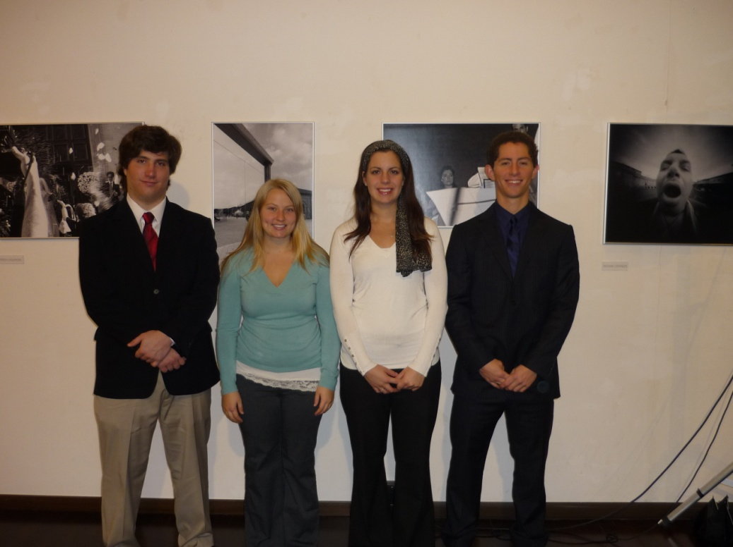As a group we all contributed equally in the data collection, writing and presenting that this project required.

# Executive Summary

The Venetian lifestyle is treasured by its inhabitants but residents expressed concern about high cost of living and housing. Due to the lack of cars and separation from the mainland, the Historical Center of Venice has a distinct pace of life.

Venetians feel that life is less hectic and they do not worry about rushing from place to place. Many Venetians mentioned that the atmosphere in Venice was different from many other places and when probed further would describe it as “relaxed” and “laid back.” However residents complained about the lack of affordable housing. Studies have shown that the cost of housing in Venice is 300% more than the average Venetian can afford.

The purpose of our project was to identify the determinants of quality of life that are important to Venetians. Our project marks a turning point in the Venice Project Center’s history as its focus shifts from Venice itself to the Venetian people.

The first goal of our project was to determine the most important quality of life topics for Venetians. We spent three weeks interviewing native Venetians and mainland residents. Overall twenty eight interviews were conducted, six of which were with Mestre residents. Although we asked a total of ten questions, we focused on “What is your favorite aspect of Venice?” and “What is your least favorite aspect of Venice?” The result of our interviews was a diagram depicting the words most frequently mentioned. In the diagram, larger words are the ones that were mentioned more frequently.

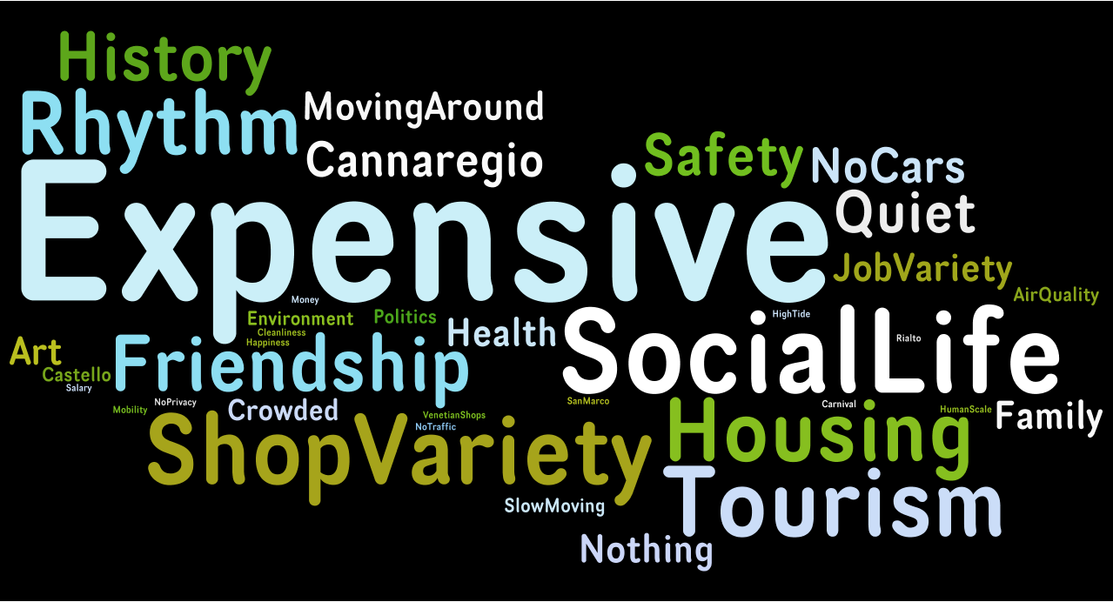

Figure Interview Frequency Diagram

Our studies identified the significant quality of life topics to be cost of living, housing, shop variety, community life, and tourism. As mentioned above, many Venetians are concerned about cost of housing. The rise in hotels and bed and breakfasts has drastically changed Venice’s housing market. As more tourists visit the city, more hotels and bed and breakfasts are needed. Residents feel that the increase in tourism has reduced the availability of affordable housing.

Figure : Number of Hotel Beds

The correlation between the number of tourists and the percentage of homes occupied by residents can be seen below in Figure 3.

Figure : Percentage of Homes Occupied by Residents and Number of Tourists

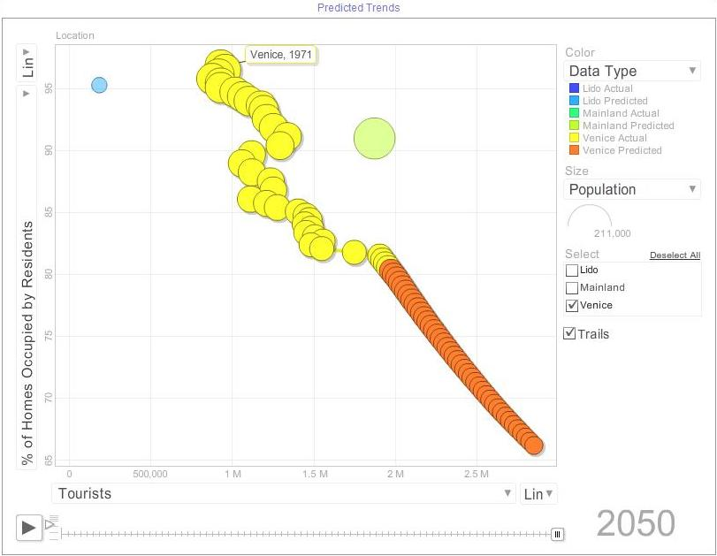

Another frequent response to “What is your least favorite aspect of Venice” was cost of living. On average, food items in Venice cost 18% more than the mainland. The increase in prices is believed to be caused by the cost of transportation from the mainland to the island. One Venetian said “I will go to the mainland to shop because it is much cheaper”.

The lack of variety of shops in Venice is a major concern among many Venetians. Many residents feel that the city lacks the stores that are needed to acquire the basic necessities of life at reasonable costs. One lady said “All our stores are becoming glass and mask shops. Pretty soon all we will have will be glass and mask shops. We can’t eat glass and masks.”

Venetians feel that tourism is a threat to their tight knit communities. “Tourism is like oil, spreading out from the center of Venice, wiping out the community life”. Many residents that we interviewed believe the Venetian community in danger of being wiped out by tourism.

Our project recommends that further steps are taken to investigate specific areas of Venetian life. One of the first areas of interest that we discovered, but were unable to investigate fully was the growing trend of people commuting into Venice every day. It appears that as more residents move out of the city, there will be a growing number of commuters who will be traveling to work from the Mainland. We also believe that further research must be done on the housing issues that the Venetian people are facing. Through our interviews we were able to identify what the government has been doing to help the residents of Venice. In actuality we found out that residents feel that the Venetian government has not taken sufficient action to help protect the city. Finally, we recommend that steps be taken to work with the organization 40xVenice to help preserve the Venetian way of life. We feel that it would be an excellent collaborator and that working with them in the future would be very beneficial.

Table of Contents

[Acknowledgments 2](#_Toc216831951)

[Abstract 3](#_Toc216831952)

[Authorship 4](#_Toc216831953)

[Executive Summary 5](#_Toc216831954)

[1 Introduction 11](#_Toc216831955)

[2 Background 13](#_Toc216831956)

[2.1 Early Years 15](#_Toc216831957)

[2.1.1 Birth Rate 15](#_Toc216831958)

[2.1.2 Daycare 16](#_Toc216831959)

[2.1.3 Schooling 16](#_Toc216831960)

[2.2 Adolescence 16](#_Toc216831961)

[2.2.1 Secondary Schooling 16](#_Toc216831962)

[2.3 Young Adult 17](#_Toc216831964)

[2.3.1 Universities 17](#_Toc216831965)

[2.4 Adult 17](#_Toc216831966)

[2.4.1 Job Market 17](#_Toc216831967)

[2.4.2 Housing 19](#_Toc216831968)

[2.4.3 Community and Family Life 21](#_Toc216831969)

[2.5 Late Adulthood 22](#_Toc216831970)

[2.5.1 Retirement 22](#_Toc216831971)

[2.6 Senior Citizen 23](#_Toc216831972)

[2.6.1 Diamond Card 23](#_Toc216831973)

[2.6.2 Service Organization 23](#_Toc216831974)

[2.6.3 Social Security Benefits 23](#_Toc216831975)

[2.7 Quality of life 24](#_Toc216831976)

[3 Methodology 26](#_Toc216831977)

[3.1 Investigating Venetians’ opinions on the quality of life 27](#_Toc216831978)

[3.2 Analyzing all relevant factors pertaining to life in Venice 29](#_Toc216831979)

[3.3 Exploring actions taken by the Venetian government or other key organizations involved 31](#_Toc216831980)

[3.4 Predicting future trends of Venice based on data 32](#_Toc216831981)

[4 Findings 35](#_Toc216831992)

[4.1 Interview Findings 35](#_Toc216831993)

[4.2 Overall Findings 35](#_Toc216831994)

[4.2.1 Favorite Aspects of Venice 36](#_Toc216831995)

[4.2.2 Least Favorite Aspects of Venice 37](#_Toc216831996)

[4.2.3 Aspects Venetians Would Like to Change 38](#_Toc216831997)

[4.2.4 Most Important Quality of Life Topic 40](#_Toc216831998)

[4.3 Findings by Demographic 41](#_Toc216831999)

[4.3.1 Male and Female 41](#_Toc216832000)

[4.3.2 Young, Middle Aged and Old 43](#_Toc216832001)

[4.3.3 Current Residents vs. Moved to Mestre 46](#_Toc216832002)

[4.3.4 Other Trends 48](#_Toc216832003)

[4.4 Cases of Interest 49](#_Toc216832004)

[4.4.1 Mary 49](#_Toc216832005)

[4.4.2 Kyle 50](#_Toc216832006)

[5 Analysis 52](#_Toc216832015)

[5.1 Housing and Hotels 52](#_Toc216832016)

[5.2 Cost of Living and Lack of Shop Variety 53](#_Toc216832017)

[5.3 Community Life and Pace of Life 56](#_Toc216832018)

[5.4 Population Decline 57](#_Toc216832019)

[6 Recommendations for Future Projects 59](#_Toc216832020)

[6.1 Working in Venice and Commuting to Venice 59](#_Toc216832021)

[6.2 Housing in Venice 60](#_Toc216832022)

[6.3 Moving in Venice 60](#_Toc216832023)

[6.4 Politics of Venice 61](#_Toc216832024)

[6.5 Population Trends 62](#_Toc216832025)

[6.6 40xVenice 63](#_Toc216832026)

[7 Conclusions 64](#_Toc216832031)

[Bibliography 66](#_Toc216832032)

[Appendix A – Annotated Bibliography 69](#_Toc216832033)

[Appendix B - Interviews 77](#_Toc216832034)

[Appendix C – Coding 108](#_Toc216832035)

[Appendix D – Categorization of Stores from Retail E’05 Project 110](#_Toc216832036)

[Figure 1 Interview Frequency Diagram 5](file:///E:\Living-Final%20Paper_12_11_PWD_11_Dectpmmethodologyedits.docx#_Toc216832095)

[Figure 3: Percentage of Homes Occupied by Residents and Number of Tourists 6](file:///E:\Living-Final%20Paper_12_11_PWD_11_Dectpmmethodologyedits.docx#_Toc216832096)

[Figure 4: Human Timeline 13](#_Toc216832097)

[Figure 5: Percentage of Venetians in the various age groups in the Historical Center of Venice 14](file:///E:\Living-Final%20Paper_12_11_PWD_11_Dectpmmethodologyedits.docx#_Toc216832098)

[Figure 6: Population and Emigration 15](#_Toc216832099)

[Figure 7: Breakdown of Venezia Job Market 19](#_Toc216832100)

[Figure 8: Number of Beds in Venice 21](#_Toc216832101)

[Figure 9: Venice's Six *Sestieri* 23](#_Toc216832102)

[Figure 10: Population of Venetians 65+ 24](file:///E:\Living-Final%20Paper_12_11_PWD_11_Dectpmmethodologyedits.docx#_Toc216832103)

[Figure 11: Quality of Life Matrix 26](#_Toc216832104)

[Figure 12: Map of Study Area 27](#_Toc216832105)

[Figure 13: Word Cloud Example 31](file:///E:\Living-Final%20Paper_12_11_PWD_11_Dectpmmethodologyedits.docx#_Toc216832106)

[Figure 14: Overall Word Cloud 31](file:///E:\Living-Final%20Paper_12_11_PWD_11_Dectpmmethodologyedits.docx#_Toc216832107)

[Figure 15 Example of Motion Chart 34](file:///E:\Living-Final%20Paper_12_11_PWD_11_Dectpmmethodologyedits.docx#_Toc216832108)

[Figure 15: Word Cloud of Favorite Aspects 37](#_Toc216832109)

[Figure 16: Favorite Aspects of Venice Pie Chart 37](#_Toc216832110)

[Figure 17: Word Cloud of Least Favorite Aspects 38](#_Toc216832111)

[Figure 18: Least Favorite Aspects of Venice 39](#_Toc216832112)

[Figure 19: Word Cloud of Aspects Venetians Would Like to Change 39](file:///E:\Living-Final%20Paper_12_11_PWD_11_Dectpmmethodologyedits.docx#_Toc216832113)

[Figure 20: Aspects Venetians Would Like to Change 40](#_Toc216832114)

[Figure 22: Most Important Quality of Life Topics 41](#_Toc216832115)

[Figure 21: Word Cloud of Most Important Quality of Life Topic 41](file:///E:\Living-Final%20Paper_12_11_PWD_11_Dectpmmethodologyedits.docx#_Toc216832116)

[Figure 23: Male Word Cloud 42](file:///E:\Living-Final%20Paper_12_11_PWD_11_Dectpmmethodologyedits.docx#_Toc216832117)

[Figure 24: Female Word Cloud 43](file:///E:\Living-Final%20Paper_12_11_PWD_11_Dectpmmethodologyedits.docx#_Toc216832118)

[Figure 25: % Dislikes for Women 43](file:///E:\Living-Final%20Paper_12_11_PWD_11_Dectpmmethodologyedits.docx#_Toc216832119)

[Figure 26: % Dislikes for Men 44](file:///E:\Living-Final%20Paper_12_11_PWD_11_Dectpmmethodologyedits.docx#_Toc216832120)

[Figure 27: 17-30 Word Cloud 45](file:///E:\Living-Final%20Paper_12_11_PWD_11_Dectpmmethodologyedits.docx#_Toc216832121)

[Figure 28: 31 - 50 Word Cloud 45](file:///E:\Living-Final%20Paper_12_11_PWD_11_Dectpmmethodologyedits.docx#_Toc216832122)

[Figure 29: 17- 30 Dislikes 46](file:///E:\Living-Final%20Paper_12_11_PWD_11_Dectpmmethodologyedits.docx#_Toc216832123)

[Figure 30: 31 - 50 Dislikes 46](file:///E:\Living-Final%20Paper_12_11_PWD_11_Dectpmmethodologyedits.docx#_Toc216832124)

[Figure 31: Current Residents Word Cloud 47](file:///E:\Living-Final%20Paper_12_11_PWD_11_Dectpmmethodologyedits.docx#_Toc216832125)

[Figure 32: Moved to Mestre Word Cloud 47](file:///E:\Living-Final%20Paper_12_11_PWD_11_Dectpmmethodologyedits.docx#_Toc216832126)

[Figure 33: Venetian Likes 48](file:///E:\Living-Final%20Paper_12_11_PWD_11_Dectpmmethodologyedits.docx#_Toc216832127)

[Figure 34: Moved to Mestre Dislikes 48](file:///E:\Living-Final%20Paper_12_11_PWD_11_Dectpmmethodologyedits.docx#_Toc216832128)

[Figure 21: Word Cloud of Aspects Venetians Would Like to Change 52](file:///E:\Living-Final%20Paper_12_11_PWD_11_Dectpmmethodologyedits.docx#_Toc216832129)

[Figure 23: Word Cloud of Most Important Quality of Life Topic 52](file:///E:\Living-Final%20Paper_12_11_PWD_11_Dectpmmethodologyedits.docx#_Toc216832130)

[Figure 25: Male Word Cloud 52](file:///E:\Living-Final%20Paper_12_11_PWD_11_Dectpmmethodologyedits.docx#_Toc216832131)

[Figure 26: Female Word Cloud 52](file:///E:\Living-Final%20Paper_12_11_PWD_11_Dectpmmethodologyedits.docx#_Toc216832132)

[Figure 27: % Dislikes for Women 52](file:///E:\Living-Final%20Paper_12_11_PWD_11_Dectpmmethodologyedits.docx#_Toc216832133)

[Figure 28: % Dislikes for Men 52](file:///E:\Living-Final%20Paper_12_11_PWD_11_Dectpmmethodologyedits.docx#_Toc216832134)

[Figure 29: 17-30 Word Cloud 52](file:///E:\Living-Final%20Paper_12_11_PWD_11_Dectpmmethodologyedits.docx#_Toc216832135)

[Figure 30: 31 - 50 Word Cloud 52](file:///E:\Living-Final%20Paper_12_11_PWD_11_Dectpmmethodologyedits.docx#_Toc216832136)

[Figure 31: 17- 30 Dislikes 52](file:///E:\Living-Final%20Paper_12_11_PWD_11_Dectpmmethodologyedits.docx#_Toc216832137)

[Figure 32: 31 - 50 Dislikes 52](file:///E:\Living-Final%20Paper_12_11_PWD_11_Dectpmmethodologyedits.docx#_Toc216832138)

[Figure 33: Current Residents Word Cloud 52](file:///E:\Living-Final%20Paper_12_11_PWD_11_Dectpmmethodologyedits.docx#_Toc216832139)

[Figure 34: Moved to Mestre Word Cloud 52](file:///E:\Living-Final%20Paper_12_11_PWD_11_Dectpmmethodologyedits.docx#_Toc216832140)

[Figure 35: Venetian Likes 52](file:///E:\Living-Final%20Paper_12_11_PWD_11_Dectpmmethodologyedits.docx#_Toc216832141)

[Figure 36: Moved to Mestre Dislikes 52](file:///E:\Living-Final%20Paper_12_11_PWD_11_Dectpmmethodologyedits.docx#_Toc216832142)

[Figure 35: Dorsoduro Shop Breakdown in 1970 55](file:///E:\Living-Final%20Paper_12_11_PWD_11_Dectpmmethodologyedits.docx#_Toc216832143)

[Figure 36: Dorsoduro Shop Breakdown in 2005 55](file:///E:\Living-Final%20Paper_12_11_PWD_11_Dectpmmethodologyedits.docx#_Toc216832144)

[Figure 37: Cannaregio Shop Breakdown in 1970 56](file:///E:\Living-Final%20Paper_12_11_PWD_11_Dectpmmethodologyedits.docx#_Toc216832145)

[Figure 38: Cannaregio Shop Breakdown in 2005 56](file:///E:\Living-Final%20Paper_12_11_PWD_11_Dectpmmethodologyedits.docx#_Toc216832146)

[Figure 39: Predicted Venetian Population and Number of Tourists 58](#_Toc216832147)

[Figure 37: Dorsoduro Shop Breakdown in 1970 59](file:///E:\Living-Final%20Paper_12_11_PWD_11_Dectpmmethodologyedits.docx#_Toc216832148)

[Figure 38: Dorsoduro Shop Breakdown in 2005 59](file:///E:\Living-Final%20Paper_12_11_PWD_11_Dectpmmethodologyedits.docx#_Toc216832149)

[Figure 39: Cannaregio Shop Breakdown in 1970 59](file:///E:\Living-Final%20Paper_12_11_PWD_11_Dectpmmethodologyedits.docx#_Toc216832150)

[Figure 40: Cannaregio Shop Breakdown in 2005 59](file:///E:\Living-Final%20Paper_12_11_PWD_11_Dectpmmethodologyedits.docx#_Toc216832151)

[Figure 42: Motion Chart 67](file:///E:\Living-Final%20Paper_12_11_PWD_11_Dectpmmethodologyedits.docx#_Toc216832152)

# Introduction

Quality of life studies are important because they give an overall understanding of the well-being of a city. These studies highlight the successful aspects of a city while exposing areas where improvements need to be made. Cities with a good quality of life often attract more business, tourism, residents, and a skilled labor force.[[1]](#footnote-2) Organizations such as Mercer, a human resource consulting firm, Urban Audit, and Euro Stat undertake the daunting task of collecting data on various aspects of cities in order to assess their quality of life. Mercer, for example, uses 10 categories and 39 criteria to evaluate 380 cities worldwide[[2]](#footnote-3). Urban Audit focuses on categories similar to Mercer’s plus others for a total of over 250 categories, depending upon an individual city’s characteristics and state of development. Unlike Mercer, Urban Audit only studies European cities.[[3]](#footnote-4) Such studies are essential to guide analysts and policy makers in finding ways to improve the environments of their cities.

The Urban Audit study allows various European cities to be compared to one another; moreover, it helps illustrate where cities excel or fall behind. For example, Urban Audit ranked 32 Italian cities based on cost to buy an apartment per square meter. Milan was top of the list with an average cost of € 2,715 per square meter and Venice ranked fifth highest with an average cost of € 2,272 per square meter. These are much higher than Italy’s average of € 1,548 per square meter. This indicates that Venice has a cost of housing situation and is a factor that lowers Venetian quality of life.

Even though Venice shares many similar characteristics to that of other Italian cities, there are various environmental differences that set it apart. A professional staff member of the Historical Archives in Venice said that “Venice is a unique city; there is no other place like it in the world.” Some of the more important factors that make up life in Venice are pace of life, tourism, cost of living, and cost of housing. Many Venetians mentioned that the city has a slow pace of life due to the absence of cars and separation from the mainland. The Venetian atmosphere is different from both the mainland of Venice and Lido, and is said to have “a less stressful environment”. Tourism plays an incredibly important role in the functioning of Venetian daily life and economy; it brings in approximately € 12 billion a year.[[4]](#footnote-5) Over the past year about two million tourists visited Venice.[[5]](#footnote-6) Furthermore, 76% of the job market in the province of Venezia is focused towards services that cater towards tourism. [[6]](#footnote-7) In addition, Venetians must deal with an exceedingly high cost of living. The cost of the 32 food items used to calculate the consumer price index in August 2008 was 18% higher in the Historical Center than in Mestre. Overall, in 2007 Venice ranked fourth out of fourteen major Italian cities for highest consumer price index which included inflation. [[7]](#footnote-8)

The population of Venice has been steadily decreasing over the past 50 years due to the high cost of living, low availability of affordable housing for residents, and an increase of tourists. Past projects that have been done by Worcester Polytechnic Institute students have focused on the city of Venice. It is important to study Venetians because they encompass the character of the city. A quality of life study is appropriate because it will gain insight on the issues of Venice that affect its residents.

The goal of our project is to determine the main factors that influence the quality of life in Venice and to make that information available in English. We collected Venetians’ opinions of their quality of life through informal interviews. We found that the most important quality of life topics were pace of life, cost of living, and cost of housing. Venetians dislike tourists because they it threaten traditional neighborhoods and stores.

# Background

In order to examine the quality of life of a Venetian, we must first examine Venetian life in its entirety from cradle to grave. We classified Venetian Life into three general stages which are further categorized into smaller sections as seen in Figure 1. 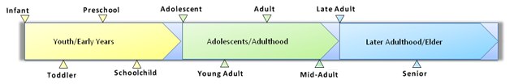

Figure : Human Timeline

Currently in Venice each age demographic is facing a specific situation. Venice’s youth population makes up an inordinately small portion of the overall population. The youth make up a total of 14% of the population in Venice compared to 18% in Italy. On the other hand, Venice’s elderly population makes up a larger portion of the populace. A total of 25% of the Venetian population is considered to be elderly, while only 19% of Italy’s population is elderly. [[8]](#footnote-9)

Coupling these facts with Venice’s distinct economic landscape and migration troubles, the life of a Venetian varies greatly across its stages. Below is a figure (Figure 4**)** that shows the percent of women and men in each age group in the “centro storico” or historical center of Venice. The historical center is an island in the lagoon, located off of the mainland of Venice. In the figure, the right hand side represents female population and the left hand side representsmale. Also, the horizontal axis of the figure is percentage, which indicates the percentage of people in each age group. There is a bulge in the upper portion of the graph indicating that there is an uneven distribution in the population, greatly weighing towards late adulthood and older.



Figure : Percentage of Venetians in the various age groups in the Historical Center of Venice

In 1980 the population of the commune of Venice was 352,453 people and in 2007 the population was documented at 269,545. In order to get a better idea of the decrease in the population of Venice, between the years of 1981 and 2001 there was a decrease of 21.7%.[[9]](#footnote-10) There are two explainations for this bottle neck effect in the population, migration and birthrate, both of which will be discussed thoroughly in the following section.

In 2006 there were 268,934 people living in the commune of Venice. Of these people, 5,736 migrated out of the city, which is about a 2.1% population decrease in one year alone.[[10]](#footnote-11) (See Figure 3) On an international scale Italy’s growth rate is extremely low. In 2000 the growth rate was documented at being 0.28% and in 2040 the growth rate is predicted to be – 0.47%.[[11]](#footnote-12) This indicates that if the emigration of people does not slow down, it will be virtually impossible to keep a native population of Venetians.

Figure : Population and Emigration

## Early Years

The early years encompass birth and the beginning stages of a child’s development.

### Birth Rate

As discussed above, the size of the youth population of Venice is steadily decreasing. A major cause in the drop in population is a low birth rate. In 2000 the birth rate of women in Italy was 1.23, which is extremely low compared to that of other cities.[[12]](#footnote-13) In order for a population to grow the average birth rate needs to be 2.1 or 2.2. Currently there are not enough children per family in Venice to replace its population. Low birth rates cause an uneven distribution between the age divisions (Figure 4).

### Daycare

Daycare is an important issue that concerns many Venetians. Due to the decreasing number of youth in Venice, many social programs and activities for children have been cut. Many daycare centers have been closed, forcing parents to find other options for childcare. A babysitter can be costly and difficult to find, therefore most women choose to stay home to raise a family. Grandparents will also take the role as babysitter, but this is not the case for every situation.[[13]](#footnote-14)

### Schooling

Around the age of three or four, children will go to “sculoa dell’infanzia” or kindergarten.[[14]](#footnote-15) Children will usually complete three years of kindergarten before moving on to primary schooling around the age of six. Primary school, which is similar to elementary school, will last five years and can be completed in a public or private school. .[[15]](#footnote-16)

At the age of 11, students will then move on to “scuola secundaria” or secondary school. There are two stages of secondary school, lower and upper secondary school. Lower secondary school lasts three years and is the equivalent of middle school. In order to move on to upper secondary school one must be awarded their “diploma di licenza media” or lower secondary school diploma. [[16]](#footnote-17)

## Adolescence

During adolescence children will move through the remaining levels of school and prepare themselves for university. This is a very important stage in life because there is a transition from child to adult and preparation for the “real world” begins.

### Secondary Schooling

Upper secondary school begins around the age of 14 and is equivalent to the United States high school. This stage of schooling will last five years, allowing students to graduate around the age of 19. The two choices for upper secondary schooling are “liceo” and “istituto”. Liceo is for those who wish to continue on to university and istituto is for more practical and technical training.

At the end of the five years in upper secondary school, a student may decide to study for their “diploma di maturita” or upper secondary school diploma. This consists of an oral exam and three written exams. If at student receives their upper secondary school diploma you are automatically qualified for enrollment in a university. [[17]](#footnote-18)

## Young Adult

Students have the option of continuing to tertiary level education or breaking into the job market. A total of 49.9% of Italians pursue tertiary education as compared to a global average of 22.9%. [[18]](#footnote-19) The job market in Venice is heavily focused on the service industry. The homogeneous job market causes Venetians to seek careers in other Italian cities or out of the country where the service industry is not as overwhelmingly dominate.

### Universities

University in Italy offers Bachelor, Masters and Doctorial degrees, also known as Laurea, Laurea Specialistica and Dottorato di Ricerca, respectively.[[19]](#footnote-20) The University of Architecture in Venice (IUAV), established in 1926, is one of the universities located in Venice. The university specializes in architecture, housing production, industrial design, visual arts and entertainment, sciences, town and country planning, and geographic information systems.[[20]](#footnote-21)

## Adult

In this stage of life it is common for one to get a job, buy a home, and start a family. One could say that this is when “real life” begins. As defined by Robyn Hartley the start of adulthood is “the transition from school to the workforce, from living in their parents’ home to living outside their parents home, and from being financially dependent to being financially independent.”[[21]](#footnote-22)

### Job Market

Approximately 2,000,000 tourists visit Venice each year. [[22]](#footnote-23) As a result, the service industry takes up approximately 80% of job market in Venice. Construction, manufacturing and agriculture make up the other 20% (Figure 6). College graduates that cannot work in the service industry must seek jobs elsewhere in Italy. One of the possible causes of the major decrease in the number of younger Venetians may be college graduates leaving the city due to the lack of variety in the job market.[[23]](#footnote-24)

Despite the lack of job variety in Venice the unemployment rate in Venice is low. Currently the unemployment rate is less than 5% while the national average of 6.2%.[[24]](#footnote-25) However, the high level of job availability does not necessarily indicate great economic conditions. In 2008 the median starting salary for Italy was €22,391 while Venice’s median starting salary was €19,100.[[25]](#footnote-26) The problem of low starting salaries, a homogeneous job market, and a high cost of living make for an economic sector that is hostile for young people trying to start their careers.

Figure : Breakdown of Venezia Job Market

### Housing

Housing in the Historical Center of Venice is very expensive which makes it difficult for Venetians to buy homes. Of the entire housing stock in Venice, only 61.7% of the houses are occupied by residents. A total of 29.3% of the houses are associated with non-resident use (such as vacationers) and then 9% of the houses are unoccupied.

Due to the large number of tourists that visit Venice each year, a major sector of the Venetian housing market is dedicated to short-term rentals. Over the last three decades the Commune of Venice has been faced with a drastic increase in rental prices. The high costs have forced residents to move out of the historical center of Venice and to the mainland. On the other hand non-residents living in Venice are willing to pay almost any price for their short stays in the city, which effectively out bids Venetians for housing.[[26]](#footnote-27) Due to this high demand for housing, the property values have increased by almost 800%, making it nearly impossible for residents to afford to live in Venice.[[27]](#footnote-28)

National, regional, and municipal laws have been put in place regulate the rental and housing market. During the 1970’s laws were passed pertaining to rental control and land regulations. Some of the first laws passed were used to help create additional public housing dwellings throughout the nation and to regulate the excessive segmentation in the rental market. These laws were used to regulate the cost of public housing and set all leases to expire after four years. Although these laws were thought to help Italians with lower incomes by putting the housing prices below the market price, it had the exact opposite effect. Landlords and property owners took this opportunity of a four year lease to evict the tenants with low incomes and find new tenants who were willing to pay higher prices for the same dwellings. In the end these laws did not help the housing market, but resulted in catering to high paying renters and short term rentals.[[28]](#footnote-29)

In an effort by the Italian government to reduce the demand for public housing and rent subsidies, as well as promote rentals for residents within city centers, a systematic plan for rent regulation was developed. In 1998 a national law offered tax breaks to individuals who rented according to the specified regulations. In the historical center of Venice there are three homogeneous housing zones which are defined. The prices for these zones are designed to be approximately twenty-five percent below market value. The reduction in these costs hoped to make renting more affordable for residents living in Venice. If an owner agreed to follow the regulations he or she is entitled to a significant tax break. [[29]](#footnote-30)

In Venice there was one particular municipal law that changed rentals and housing drastically. The Commune di Venezia passed Law 49 in 1999 that was intended to deal with the expected increase in tourism due to the 2000 Jubilee Year celebration. This law eased rental rules and allowed the creation of bed and breakfast type hotels. Usually bed and breakfasts are run out of local houses and involve the rental of spare rooms.[[30]](#footnote-31)

Figure : Number of Beds in Venice

In the graph above, the number of available beds has increased significantly since 1999. The increase was caused by Law 49 that the Commune di Venezia passed in 1999.

A 2004 study by Urban Audit showed the cost to buy an apartment in Venice was € 2,272 per square meter. The average of Italy was € 1,548 per square meter. Venice had the fifth highest cost of housing compared to 32 different cities in Italy.[[31]](#footnote-32) The costs of non-residential dwellings are based on *sestieri*. Weekly and monthly rental costs behave exactly opposite of each other. In 2001 the most popular rental area of the historical center of Venice was San Marco. San Marco also happened to have the most expensive monthly rentals, but the least expensive weekly rentals. It was also shown that the monthly rental costs decreased as the distance from the main tourist attractions increased. In this situation the exact opposite was true for weekly rentals. It costs less to have a weekly apartment near the main tourist attractions.[[32]](#footnote-33)

Overall it is a daunting and difficult task for a Venetian to buy a home or apartment. The tourist industry has caused a large influx in the amount of hotels and bed and breakfasts. Also, there is an increase in the amount of houses that are rented out to tourist. Tourists that come to Venice will pay almost any rental price. Venetians cannot compete with the high housing costs.

### Community and Family Life

Similar to that of many other Italian cities, family life is very important in Venice. Celebrations and Sunday dinners are still very common where grandparents, aunts, uncles, and cousins are invited over to spend time together. It is also very typical for children stay with their parents until they are married, which makes the families very close nit. Even after children move out, often they will move back in to help their aging parents.[[33]](#footnote-34)

Along with family life, community life is also important. Venice is divided into six different districts, which are commonly known as *sestieri*. Within these *sestieri* there are different parishes, which are small social and administrative units of Venice. *Sestieri* are what make up the various communities throughout Venice. It is very common for one to live in the same *sestieri* for their entire life. Individuals who grow up in a specific *sestieri* often have a close connection to it for their entire life. The graph below shows the six different *sestieri* in Venice. The Grand Canal is the main divider for which the *sestieri* are split apart (Figure 8).[[34]](#footnote-35)

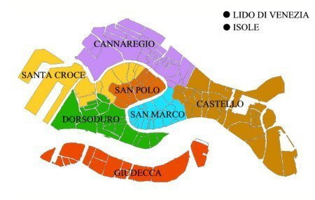

Figure : Venice's Six *Sestieri*

## Late Adulthood

The bridges and narrow alleys pose as challenges to elderly Venetians. It is in this stage of Venetian’s life that they begin to think about how they are going to be taken care of as they age. The older Venetians would typically have downsized into a smaller house at this point. Due to Venice high cost of housing, downsizing is quite normal for aging Venetians.[[35]](#footnote-36)

### Retirement

Italy has become a popular place for retired people from around the world. Not only is Italy’s lifestyle valued, but it also has lower taxes than other places. All income and federal gains are taxed a mere 12.5% compared to other European countries that tax up to 40%. The low taxes attract other Europeans to retire in Italy instead of their own country.[[36]](#footnote-37)

## Senior Citizen

In 2005 senior citizens made up 28% of the population and in 2007 they make up 29% of the population. If this trend continues, the elderly will make up a third of the historical center’s population by 2015.[[37]](#footnote-38)



Figure : Population of Venetians 65+

### Diamond Card

Venice offers a discount card to senior citizens called the Diamond Card. The purpose of the card is to help the elderly with the prices of primary goods and services in Venice. For example, the Diamond Card can be used at the grocery store, pharmacy, large retailers, and hardware stores.[[38]](#footnote-39)

### ****Service Organization****

**Moving around in Venice affects the elderly greatly as many have limited mobility. Since the majority of transportation is either done on foot or by boat, elderly Venetians need some help moving around the city. The organization of Disabled, Elderly, and Mental Help services is in charge of making sure that all the areas of Venice have easily accessible entrances and exits.**[[39]](#footnote-40)

**A card was created by the organization called the** “Carta dei Servizi” or Service Card.[[40]](#footnote-41) There are various cards that assist all age groups and there are many services that the card offers. Depending on your individual situation, the type of card you receive will be determined by the organization.[[41]](#footnote-42)

### ****Social Security Benefits****

Since there is such a large portion of older people, many services have been created to help out the elderly and make their life more enjoyable. The Italian Social Security System benefits employed persons, including domestic employees working in other countries. Almost all of a retiree’s income comes in the form of Social Security Benefits. In Italy there is also an early retirement provision, which has been shown to distort choices in favor of early retirement.[[42]](#footnote-43)

## Quality of life

Quality of life is defined by the free dictionary as “your personal satisfaction or dissatisfaction with the cultural or intellectual conditions under which you live (as distinct material comfort)”.[[43]](#footnote-44) In other terms, quality of life is more of a person’s feelings or emotional state about their personal life. Although there is no particular way to measure quality of life quantitatively, it can be measured by surveying people and determining their emotional state. Mercer’s Human Resource Consulting LLC states that “One may live in the highest ranked city in terms of quality of life and still have a very bad quality of life because of unfortunate personal circumstances (illness, unemployment or loneliness, etc.).”[[44]](#footnote-45)

Another term that is used to describe the factors that affect a person’s life is quality of living. Quality of living is slightly different from quality of life. It has certain standards such as health issues, housing, consumer goods, personal safety and education that can be measured quantitatively. Our project is more concerned with quality of living, but due to the confusion caused by this subtle but distinct difference, we will simply refer to what our project is covering as quality of life.

Various studies have been done to determine the quality of life of cities and then rank them. A study was done in 2005 by the *Economist* which created a Worldwide Quality of Living Index. A total of 111 different countries were ranked, with Italy being fifth. [[45]](#footnote-46) According to Mercer Human Resources Consulting LLC some of the factors that affect the quality of life throughout the world are political and social environment, socio-cultural environment, economic environment, medical and health considerations, schools and education, public service and transportation, recreation, consumer goods, housing, and natural environment.[[46]](#footnote-47)

Frequently mentioned topics such as cost of living and housing corresponded with the topics previously established by Mercer, *The Economist* and Urban Audit. Community life was only mentioned by the *Economist* and pace of life (which we will refer to as “rhythm” for reasons explained in Section ) was not a quality of life topic in any of the three studies. However we felt that they are very important to the Venetian quality of life therefore the topics were included in our matrix.

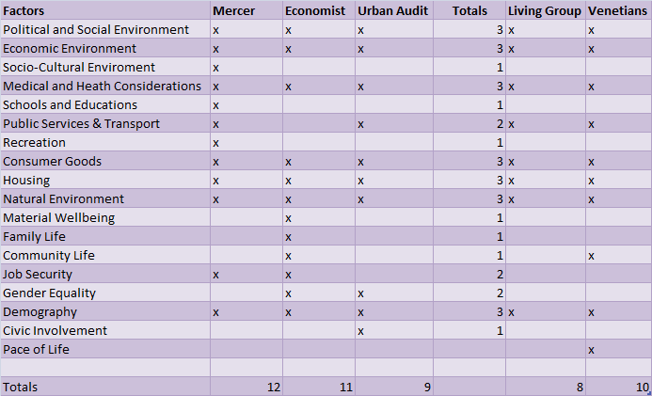

Figure : Quality of Life Matrix

# Methodology

Our mission is to investigate the determining factors of the quality of life of Venetians and to compile our findings into an accessible form for future projects. Below is a list of objectives that we completed in order to achieve our goal.

1. To investigate the Venetians' opinions on quality of life.
2. To analyze all relevant factors pertaining to living in Venice.
3. To explore actions taken by the Venetian government or other key organizations involved
4. To predict future trends of Venice based on compiled data.

We conducted our research in the Historical Center of Venice. This is not to be confused with the Commune of Venice, which also includes Lido and the mainland. We did however include data about Lido and the mainland where it was necessary for a comparison. We interviewed five people who previously lived in Venice, but moved to Mestre or Lido. It was important to gather opinions from those who left Venice because it shows different opinions about Venice. This data will be sufficient enough to draw conclusions and make comparisons between the Historical Center of Venice and the other parts of the Commune of Venice.

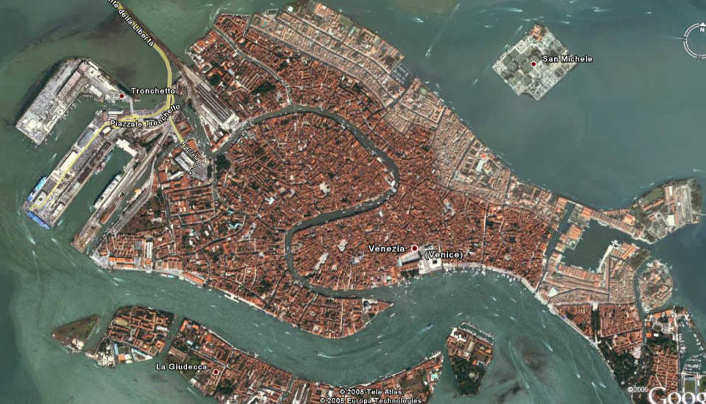

Figure : Map of Study Area

Our goal was to rank the relative importance of quality of life topics specific to Venetians. Some of the topics that we studied were transportation, job market, housing, cost of living, shop retail, health, tourism, and family life. We did not focus on topics that specifically related to the younger or older age groups because there are two other project groups in Venice focusing on those generations. After we decided on our final quality of life topics in Venice, we were able to look at them more in depth. Through data we collected from the past and present we were then able to predict future trends.

## Investigating Venetians’ opinions on the quality of life

To fulfill our first objective and supplement the following objectives we conducted informal interviews while in Venice. The goal of this objective was to collect opinions from the Venetians relating to their quality of life. We completed this goal in within the first three weeks because the data was used to aid our following objectives.

We choose to conduct informal interviews because it was the most appropriate method for collecting opinions from the Venetians. Informal interviews allowed us to ask follow up questions, which led to more in depth answers. Next we determined the criteria for our sample pool. First and foremost, all Venetians we interviewed must have lived in Venice for at least one year and were able to speak English well enough to answer our questions. The sample needed to spread out equally over the middle aged group, which we determined to be between twenty five to sixty five years old. As described in Section 2.4, adulthood usually begins after college graduation or when one enters the job market. The end of our age boundary is sixty five because this is the recognized aged for retirement in Venice. Another important variable in our sample pool was the residence of the interviewee. We purposely looked for five or six people who lived in the Historical Center but moved to Lido or Mestre. These interviewees gave us insight on what quality of life topics were important them but were not satisfied by living Venice. Another variable in our sample pool was gender. It was important to have an equal representation of the above variables in our sample pool to ensure the validity of the interviews. A valid sample pool is necessary to accurately reflect the true opinions of Venetians. [[47]](#footnote-48)

We conducted our interviews over the course of four weeks between the hours of 10 a.m. and 11 a.m. and then 3 p.m. and 4 p.m. One person in each pair was responsible for asking questions and following up with probe questions, while the other was taking notes. This ensured that every question was covered and each response was properly documented. We took advantage of the opportunistic sampling method, which involves following new leads during field work and taking advantage of unexpected flexibility. [[48]](#footnote-49) The opportunistic sampling method allowed us to select people as we found them in the field. This method is not very scientifically accurate, but due to the language barrier and time limit we could not use a more complex method.

Below is a list of standard questions that were asked in each interview.

1. What is your name?
2. What is your age?
3. Are you currently living in Venice?
4. How long have you lived in Venice?
5. How long have your parents living in Venice?
6. What is your occupation?
7. What is your favorite characteristic of Venice?
   1. Why? or other probe question
8. What is your least favorite characteristic of Venice?
   1. Why? or other probe question
9. If you could change one thing about Venice, what would it be?
   1. Why? or other probe question
10. What do you feel is an important factor that makes up your quality of life?

After each interview session the collected interview data was entered into an Excel document under the correlating category (Appendix C – Coding). We created a matrix in order to make our organizing and analyzing easy and straight forward. This matrix helped aid us in completing objective two, which was to depict general trends. The interview transcripts are located in Appendix B - Interviews.

## Analyzing all relevant factors pertaining to life in Venice

The purpose of this objective was to establish a relative ranking of quality of life topics that were important to Venetians based on opinions gathered during interviews.

Through preliminary research, a list of quality of life topics was compiled based on topics most common between Mercer, the *Economist* and Urban Audit. This table is depicted in the Background. (Figure 10: Quality of Life Matrix) We choose topics (marked with an X) because they were common to all three sources. The only exception is public service and transportation, but we felt that it was important due to Venice’s location in the lagoon and lack of cars. The next step involved more in depth analysis of the subtopics and details of each indicator.

The interview transcripts were dividing up into more specific categories to encode the data.[[49]](#footnote-50) The simple categories were as follows: name, age, gender, number of children, occupation, and years lived in Venice. Four of the columns contain direct quotes from the last four questions in the interview. An adjacent column was used to categorize the quotes into quality of life topics. For the table of coded words, see Appendix C.

Once we had the keywords organized, we used a graphic called a frequency diagram, or Word Cloud to represent our findings[[50]](#footnote-51). We also used the word clouds to compare our results across different demographic categories. A word cloud is a jumble of different words and phrases of different sizes relative to the number of times the word was entered into the input text. If the word “Word” was entered into the input text three times, the word “Time” was entered in twice, and the word ”Money” was entered once, Time's font size would be twice Money's, and Word's font size would be 3/2 that of Time's. An example of this Word Cloud is shown below.



Figure : Word Cloud Example

We entered all of the key words from our interviews into the input text and generated a Word Cloud which is shown below.



Figure : Overall Word Cloud

We then marked each keyword under one of the main quality of life topics such as cost of living, health, or safety. After that we organized the subjects into an excel spreadsheet and began to tally the number of responses that fit into each category. Our final list of quality of life topics were ranked based on the number of times they were referred to in the interviews. We focused on the top three topics that Venetians liked and disliked for further research and objectives.

## Exploring actions taken by the Venetian government or other key organizations involved

The purpose of this objective was to determine the positive and negative effects of government aid regarding quality of life issues addressed in the interviews. Furthermore, gaps were also determined through the completion of objective one and two. During the later phases of our interviews we were able to incorporate questions about government laws, policies or other actions to see how Venetians felt towards these topics. Our interviews gave us a good insight as to what the Venetian government has and has not been doing to aid the people.

In order to find the various laws and programs that have been implemented in Venice we had to search the many databases on the web. The main types of programs we are looking for are ones that have been implemented to deal with or even counter act some of the various living situations in Venice. One useful source was an Interactive Qualifying Project completed in 2001 by Worcester Polytechnic Institute students. [[51]](#footnote-52) The IQP highlighted housing issues in Venice and a law passed in 1999 that did not improve the housing situation.

A major advantage to being in Venice was that we were able to meet and talk to the various groups that are trying to improve the living qualities of the city. An example of this is 40xVenice which is an organizations founded in 2008 dedicated to improving life in Venice for middle aged people. Within 40xVenice there is a group called “Living in Venice” which addressed concerns similar to our project. We were able to meet with the group’s coordinator and find out information about the organization and what they are aiming to do.

Also, we talked to Venetians to find out about government programs and laws that have been implemented to aid and serve the people. During the later phases of objective one we were able to ask questions in our interviews about the local problems in Venice to determine the gaps. We did this to get a general consensus as to how the local population feels. We also wanted to see if they have opinions on what could be potentially done to fix any problems. We not only wanted to focus on the programs that have had negative effects on the people, but also the ones that have had positive effects on the people. There are going to be various kinds of programs that have been implemented in the city and we wanted to be sure that we highlighted programs that have had both positive and negative effects on the city.

As there are many programs that are trying to improve the city, not all of them are effective. For example, one governmental program was put in place to help Venetians buy houses. A list of people that needed help buying a house and when your name came up, the government would give you a certain amount of money. Unfortunately, the money that was given out by the government was not enough to help people purchase a house. Thorough examples like this we were able to find out more insight into the Venetian government and the policies and programs they have implemented.

## Predicting future trends of Venice based on data

Our final objective we accomplished was to predict future trends in Venice. By compiling and studying data pertaining to quality of life, we were able to extrapolate possible emerging trends. Such predictions might prove useful to the various organizations intending on helping Venice. We hope that our predictions may help these organizations address dangerous trends before they become a problem. Not only do we want these organizations to address dangerous trends, but to also understand positive trends so that they might be replicated elsewhere.

In terms of predicting future trends in Venice, we created a series of tables and graphs to display all of the data that we gathered. Many population and demographic trends have already been predicted, but for ones that have not, we were able to calculate our own future trends. Once we gathered or created this data, we then displayed it in on a Motion Chart as seen below.



Figure 15 Example of Motion Chart

When we began extrapolating our data, we first attempted to plot out the basic type of curve that the data indicated. Once we had identified what type of equation governs the data, we then selected the appropriate formula for extrapolating out our predictions. Depending on the curve of the data we collected we then decided between linear extrapolation, polynomial extrapolation, and exponential extrapolation.[[52]](#footnote-53) The same is true for our interpolation methods. The method we used was based off what form of curve the data appears to be taking.[[53]](#footnote-54) Once we had selected the appropriate method, we then proceeded with fully plotting out our data trends.

We have decided that using our Wiki-Venice “Living in Venice” page was the best way to display our data for ourselves and the public (<http://wikivenice.org/index.php/Venipedia:Living_in_Venice>). Not only is the wiki page viewable by everyone, but the wiki is an easily updatable encyclopedia. Therefore if anyone else wants to add further information about Venetian life, they can do so very easily. We have displayed the data we have collected not only in essay form, but also by the use of graphics and visuals. The advantage of the graphics is that can be easily interpreted and will display a large amount of quality information.

The final result of our project was a report containing all of our research and the graphics we have produced as part of our final report. In addition to this, we have finished a presentation summarizing the results of our findings that we can present to our advisors and collaborators. Finally, we have our “Living in Venice” Wiki Pages with the results of our findings and some interactive versions of the data we have collected. This is a comprehensive collection of our work research while studying in Venice.

# 

1. Feldmann, Berthold. *Eurostat.* March 23, 2008. http://epp.eurostat.ec.europa.eu/cache/ITY\_OFFPUB/KS-SF-08-082/EN/KS-SF-08-082-EN.PDF (accessed October 5, 2008). [↑](#footnote-ref-2)
2. *Mercer.* www.imercer.com/uploads/common/pdfs/definingqualityofliving.pdf. (accessed September 8, 2008). [↑](#footnote-ref-3)
3. *Urban Audit.* http://www.urbanaudit.org/ (accessed October 5, 2008). [↑](#footnote-ref-4)
4. Povoledo, Elisabetta. *Venetian transport leaves tourists high and dry.* January 21, 2008. http://www.iht.com/articles/2008/01/21/europe/venice.php (accessed December 7, 2008). [↑](#footnote-ref-5)
5. Venice in Peril - The British Committee for the Preservation of Venice. http://www.veniceinperil.org (accessed September 15, 2008). [↑](#footnote-ref-6)
6. Citta' di Venezia. http://www.comune.venezia.it (accessed September 15, 2008). [↑](#footnote-ref-7)
7. Urban Audit. http://www.urbanaudit.org/ (accessed October 5, 2008). [↑](#footnote-ref-8)
8. *Citta' di Venezia.* http://www.comune.venezia.it (accessed September 15, 2008). [↑](#footnote-ref-9)
9. Ibid. [↑](#footnote-ref-10)
10. Istituto nazionale di statistica. http://www.istat.it/english/databanks.html (accessed October 5, 2008). [↑](#footnote-ref-11)
11. "US Census Bureau." US Census Bureau. http://www.census.gov/ (accessed 09 15, 2008). [↑](#footnote-ref-12)
12. "US Census Bureau." *US Census Bureau.* http://www.census.gov/ (accessed 09 15, 2008). [↑](#footnote-ref-13)
13. "Italy's Way of Life." http://library.thinkquest.org/J0112187/italy\_way\_of\_life.htm (accessed 09 29, 2008). [↑](#footnote-ref-14)
14. *Citta' di Venezia.* http://www.comune.venezia.it (accessed September 15, 2008). [↑](#footnote-ref-15)
15. *Citta' di Venezia.* http://www.comune.venezia.it (accessed September 15, 2008). [↑](#footnote-ref-16)
16. Secondary Schooling in Italy [↑](#footnote-ref-17)
17. Secondary Schooling in Italy [↑](#footnote-ref-18)
18. <http://www.iuav.it/English-Ve/Department/index.htm> [↑](#footnote-ref-19)
19. The Italian Educational System. http://www.ilsegnalibro.com/educatio.html (accessed October 12, 2008). [↑](#footnote-ref-20)
20. Citta' di Venezia. http://www.comune.venezia.it (accessed September 15, 2008). [↑](#footnote-ref-21)
21. Hartley, Robyn. *Adulthood 'The time you get serious about the rest of your life'.* [↑](#footnote-ref-22)
22. Venice in Peril - The British Committee for the Preservation of Venice. http://www.veniceinperil.org (accessed September 15, 2008). [↑](#footnote-ref-23)
23. Central Intelligence Agency. October 2, 2008. https://www.cia.gov/library/publications/the-world-factbook/geos/it.html (accessed September 20, 2008). [↑](#footnote-ref-24)
24. Central Intelligence Agency. October 2, 2008. https://www.cia.gov/library/publications/the-world-factbook/geos/it.html (accessed September 20, 2008). [↑](#footnote-ref-25)
25. *Payscale.* http://www.payscale.com/research/IT/City=Venice/Salary (accessed November 13, 2008). [↑](#footnote-ref-26)
26. Martin, Jonathan, Geoffery San Antonio, Nathan Starbard, and Herbert Wibisono. "Assessment of the Non-resident Housing Market in Venice, Italy." IQP, Venice, Italy, 2001. [↑](#footnote-ref-27)
27. Venice in Peril - The British Committee for the Preservation of Venice. http://www.veniceinperil.org (accessed September 15, 2008). [↑](#footnote-ref-28)
28. Martin, Jonathan, Geoffery San Antonio, Nathan Starbard, and Herbert Wibisono. "Assessment of the Non-resident Housing Market in Venice, Italy." IQP, Venice, Italy, 2001. [↑](#footnote-ref-29)
29. Martin, Jonathan, Geoffery San Antonio, Nathan Starbard, and Herbert Wibisono. "Assessment of the Non-resident Housing Market in Venice, Italy." IQP, Venice, Italy, 2001. [↑](#footnote-ref-30)
30. Martin, Jonathan, Geoffery San Antonio, Nathan Starbard, and Herbert Wibisono. "Assessment of the Non-resident Housing Market in Venice, Italy." IQP, Venice, Italy, 2001. [↑](#footnote-ref-31)
31. Urban Audit. http://www.urbanaudit.org/ (accessed October 5, 2008). [↑](#footnote-ref-32)
32. Martin, Jonathan, Geoffery San Antonio, Nathan Starbard, and Herbert Wibisono. "Assessment of the Non-resident Housing Market in Venice, Italy." IQP, Venice, Italy, 2001. [↑](#footnote-ref-33)
33. Family Life in Italy [↑](#footnote-ref-34)
34. Click, Venice. *Venice's Six Sestieri.* 2000. http://www.veniceclick.net/Guide/Sestieri-Venice.htm (accessed November 14, 2008). [↑](#footnote-ref-35)
35. Aenlle, Conrad de. "AtHomeAbroad: Reading the fine print on an Italian retirement." *International Herald Tribune*, November 23, 2002: 1-2. [↑](#footnote-ref-36)
36. Aenlle, Conrad de. "AtHomeAbroad: Reading the fine print on an Italian retirement." *International Herald Tribune*, November 23, 2002: 1-2. [↑](#footnote-ref-37)
37. "T01: Residenti Previsti Al 31.12 Di Ogni Anno - Centro Storico." Città di Venezia: Modello di Previsione Demografica. [http://www.comune.venezia.it/flex/cm/pages/ServeBLOB.php/L/IT/IDPagina/4703](http://www.comune.venezia.it/flex/cm/pages/ServeBLOB.php/L/IT/IDPagina/4703" \t "_blank) (accessed 10/04, 2008). [↑](#footnote-ref-38)
38. *Citta' di Venezia.* <http://www.comune.venezia.it> [↑](#footnote-ref-39)
39. *Citta' di Venezia.* <http://www.comune.venezia.it> [↑](#footnote-ref-40)
40. "Carte Dei Servizi: Direzione Politiche Sociali Partecipative e Dell'Accoglienza." Città di Venezia. <http://translate.google.com/translate?u=http://www.comune.venezia.it/flex/cm/pages/ServeBLOB.php/L/IT/IDPagina/15318&hl=en&ie=UTF-8&sl=it&tl=en> (accessed 11/04, 2008). [↑](#footnote-ref-41)
41. Aenlle, C. d. (2002, November 23). AtHomeAbroad: Reading the fine print on an Italian retirement. *International Herald Tribune* , pp. 1-2.

    [↑](#footnote-ref-42)
42. Brugiavini, Agar. "Social Security and Retirement in Italy." http://ideas.repec.org/p/nbr/nberwo/6155.html (accessed October 1, 2008). [↑](#footnote-ref-43)
43. *Free Dictionary .* http://www.thefreedictionary.com/quality+of+life (accessed September 28, 2008). [↑](#footnote-ref-44)
44. *Mercer.* www.imercer.com/uploads/common/pdfs/definingqualityofliving.pdf. (accessed September 8, 2008). [↑](#footnote-ref-45)
45. *Economist*. (n.d.). Retrieved September 14, 2008, from Quality of Life Index: www.economist.com/media/pdf/QUALITY\_OF\_LIFE.pdf [↑](#footnote-ref-46)
46. *Mercer.* www.imercer.com/uploads/common/pdfs/definingqualityofliving.pdf. (accessed September 8, 2008). [↑](#footnote-ref-47)
47. Royce A. Singleton, Jr. *Approaches to Social Research.* New York: Oxford New York, 1988. [↑](#footnote-ref-48)
48. Royce A. Singleton, Jr. *Approaches to Social Research.* New York: Oxford New York, 1988. [↑](#footnote-ref-49)
49. Royce A. Singleton, Jr. *Approaches to Social Research.* New York: Oxford New York, 1988. [↑](#footnote-ref-50)
50. *Word Cloud.* www.wordle.net (accessed October 5, 2008). [↑](#footnote-ref-51)
51. Martin, Jonathan, San Antonio Geoffery, Starbard Nathan, and Wibisono Herbert. *Assessment of the Non-Residential Housing Market in Venice Italy.* Interactive Qualifying Project, Venice, Italy: WPI, E01 [↑](#footnote-ref-52)
52. *Mathematica: Extrapolation.* http://documents.wolfram.com/mathematica/Built-inFunctions/AdvancedDocumentation/DifferentialEquations/NDSolve/ODEIntegrationMethods/ControllerMethods/Extrapolation.html (accessed October 28, 2008). [↑](#footnote-ref-53)
53. Bourke, Paul. *Interpolation Methods.* December 1999. http://local.wasp.uwa.edu.au/~pbourke/miscellaneous/interpolation/ (accessed October 28, 2008). [↑](#footnote-ref-54)