Contents

1. Introduction 2

2. Background 5

2.1. Italian Heritage 6

2.1.1. The Renaissance and the Roman Catholic Church 6

2.1.2. The Roman Catholic Church Government 8

2.1.3. Italian Government 8

2.1.4. Venitian Government: Soprintendenza ai Beni Ambientali e Architettonici 8

2.2. Preservation of Venetian Heritage 9

2.2.1. Flood of 1966 9

2.2.2. UNESCO 10

2.2.3. Private Committees 11

2.3. Data Visualization Standards 11

3. Methodology 12

3.1. Preliminary Work 13

3.1.1. *Domain of Inquiry and Definitions* 13

3.1.2. *Area of Study* 13

3.1.3. *Access to Churches* 14

3.2. Analyzing and Organizing the Data 14

3.2.1. Following O'Reilly Data Visualization Standards 15

3.2.2. Determine changes to current schema 15

3.2.3. Analyze for Quality and Completeness 15

3.3. Identifying Restoration Priorities 15

3.3.1. Assessing Damage 15

3.3.2. Rankings 15

3.4. Identifying Missing information and Future projects 16

3.4.1. Determine Missing Attributes 16

3.4.2. Determine Missing Entries (Artifacts or Bells) 16

3.4.3. Formulate possible future projects 16

3.5. Develop and Demonstrate the Prototype 16

3.5.1. Obtain requirements from UNESCO for the World Cafe 17

3.5.2. Design and Implement Prototype 17

3.5.3. Demonstration of Prototype 17

4. Bibliography 18

Appendix A 19

LITERATURE REVIEW/ANNOTATED BIBLIOGRAPHY 19

# Introduction

Once standing an astounding height of 180 and 121 feet, in the hills of Afghanistan, the two Buddhas of Bamyan now lay in rubble.[1] In 2001, the Taliban destroyed the Buddhas of Bamyan. This act of terrorism caused many preservation groups, such as the United Nations Educational Scientific and Cultural Organization (UNESCO), to take an active role in restoration efforts at this site. The monumental task of restoring these important statues would cost approximately 50 million dollars. This event demonstrates the importance placed on heritage worldwide. Organizations are willing to fund millions of dollars in preservation efforts to an impoverished country that has ten percent of its population suffering from hunger.[2] Afghanistan has always endured poverty, yet minimal efforts and attention were shown globally to change the situation. However, the Buddhas of Bamyan catastrophe caught much publicity and groups around the world were proactive in helping out in any way possible. This occurrence demonstrates how much people care about heritage and its preservation.

Similarly, in 1966 a devastating flood in the city of Venice, Italy destroyed many pieces of cultural importance.[3] As a result, this disaster aroused the same response, and the world called for preservation of Italian heritage.[4] Italy contains a vast amount of art from many different historical periods. As the origin of the Renaissance, the great cultural rebirth rapidly spread throughout Europe and other parts of the world.[5] Many Italian artists, such as Michelangelo, Raphael, and Leonardo da Vinci, rose from this era and composed much of the art that is widely appreciated and visited by people today.[6] The Roman Catholic Church, the largest property owner in the world, commissioned much of the art in Italy. As a result, Italian heritage has deep religious roots. Peoples of various religions visit these churches to appreciate the art they hold. Every year people come from all over to see these amazing works of art causing Italy to be one of the top ten tourist’s destinations in the world. In one year, twenty million people visit Venice alone.[7] UNESCO recognizes the rich heritage embedded in Italy and has identified forty-three properties of historical importance on their World Heritage List, the largest number of properties out of any country world wide.[8]

In 1987, UNESCO recognized Venice, Italy as a site of cultural importance; this was the first city in its entirety to be singled out for preservation[9]. Within a two year period, UNESCO dedicated $544 million to culture, 12.1% of their yearly budget.[10] UNESCO uses it funds to work with and help the *Soprintendenza di Veneto* restore pieces of art and architecture. In reaction to the flood of 1966, over 50 private preservation groups have formed to fund the restoration efforts in Venice. Between 1999 and 2002, the private committees raised over 9 million US dollars to aid in the efforts of preserving Venice.[11] One such group, Venice in Peril, raised over £50,000 to donate toward culture preservation in 2007.[12] Substantial work has been done to increase awareness of Venetian heritage and receive aid in preservation efforts. Twenty years ago, Worcester Polytechnic Institute (WPI) students began contributing to these preservation efforts through various Interactive Qualifying Projects (IQP). Through these projects, WPI students have cataloged public art data and laid the groundwork for an organization, PreserVenice, a non-profit organization dedicated to preserving Venice. IQP teams from WPI have produced a comprehensive guide to cataloging bell towers and artifacts found within floors of churches, with the ability to update the catalogs[13]. The past IQP teams and preservation groups share a common goal in trying to make their findings public, so they can create awareness to enhance preservation efforts.

Thus far, extensive work has been done to collect data on public art,bells, and artifacts embedded within church floors. All the churches that are part of the WPI study have been visited. Much of data about churches in general has been collected. However, preliminary efforts have been made in collecting data on the artifacts found in their floors. Many bell towers have not been visited yet, and therefore, the majority of data regarding Venetian bells is missing. Of the bells visited, many pertinent characteristics have not been documented. Nearly all the data regarding public art has been collected. Unfortunately, most of the collected data is not being used because it is inaccessible, and some of it lacks intuitive organization. Also, each project has used a different method for organizing the collected data. The result is a data system with information that is outdated and lacks quality. By organizing the data, a system can be installed which displays the collected data online and allows others to contribute.

For our project we plan to assist in the preservation efforts in Venice by increasing awareness. We propose to organize the existing data on public art into a catalog so that gaps and inconsistencies in information can be assessed. We also plan to further, if not complete, the collection of data of artifacts embedded in church floors and bells from the gaps and inconsistencies found in the present catalog. The goal of the catalog is to organize the data to facilitate publishing. By publishing the data we strive to increase awareness of Venetian heritage. We also look to accomplish a system to bestow credit to the donors, since no alterations or additions can be made to the piece of heritage.

# 

# Background

Beginning in 1896, The Olympics Opening ceremony has been bringing peoples of various nations together in one location. This year, 204 countries entered the Beijing National Stadium wearing clothing that represents their specific cultures with pride.[14] Globally, high importance has been placed on this international event because the participating nations are unified by appreciating and respecting their competitor’s heritage. Culture is universally recognized through beliefs, arts and monuments that have been established throughout history and exist today. China’s Great Wall stops time to a period when barbarians were ravaging the country; it’s amazing to imagine constructing a wall so immense in a much simpler time. Today, one almost stops to worship Athena at the steps of the Parthenon at the Acropolis because the building is truly awe-inspiring; it’s enough to transport anyone back to ancient Greece. Finally, it’s impossible not to remember the struggle for a “more perfect union” when gazing upon Jefferson’s Monticello.[15] These architectural wonders engage people with the respective country’s history and culture. By merely visiting these sites, one feels closer with the culture and natives. Without preservation, these historically and culturally important landmarks would forever be lost and their nation’s identity forgotten.

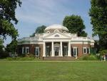

Figure 3: Monticello

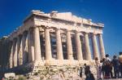

Figure 2: The Parthenon

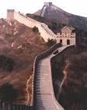

Figure 1: Great Wall of China

Many preservation organizations have been established to ensure these and other historically significant sites are maintained. UNESCO, the United Nations Educational, Scientific and Cultural Organization, is one of the more well noted preservation groups and was established in 1845. UNESCO has been an integral part in funding the preservation of historical sites. For example, 12.1% of UNESCO’s 544 million U.S. dollar budget went towards preserving cultural heritage efforts. In 1972, UNESCO adopted the treaty, “[Convention concerning the Protection of the World Cultural and Natural Heritage](http://whc.unesco.org/?cid=175)”. This treaty declared UNESCO’s international devotion to the preservation of cultural and natural heritage. UNESCO also created a World Heritage List composed of 878 historical sites worldwide that were deemed culturally significant. The Great Wall of China, the Acropolis and the Monticello were all place on the list in 1987.[16]

In that same year, Venice, Italy was the first city in its entirety to be placed on the World Heritage List as a site of extreme cultural importance. UNESCO and many other preservation groups have taken interest in saving Venetian heritage because this civil engineering masterpiece is slowly sinking. The city’s 118 islands are supported by thousands of wooden poles, which over time began sinking. The waning support of these wooden poles and the er-rising sea levels are endangering Venice. This is problematic because years of Venetian heritage are embodied in this unique city including 5,000 pieces of public art, over 80 churches with precious artifacts embedded in their floors and many ancient bells. Without preservation, Venice’s identity could be lost forever

## Italian Heritage

The following is about the influence the Renaissance and the Roman Catholic Church have on Italian Heritage.

### The Renaissance and the Roman Catholic Church

Beginning in the 13th century and ending in the 17th century, Italy was the birthplace of the Renaissance. This cultural movement is responsible for most of Italy’s masterpieces that are treasured by many and account for the numerous amounts of tourism Italy receives every year. Twenty million tourists visit Venice, Italy in one year alone. Great structures recognized internationally were constructed during this time period, such as St. Peter’s Basilica, the Church of San Giorgio Maggiore and the Basilica di Santa Maria della Salute.[17]

Religion was the subject for most of the art produced during this era for many reasons. In 1439 the printing press was invented in Europe by Johann Gutenberg. This technological advance made books more accessible and therefore made the Bible more available to people. Furthermore, the capital of the Roman Catholic Church is seated in Italy and therefore 97% of Italy’s population is Catholic. Italy also contains more Catholic churches per capita than any other country world wide. Many of the Italian artists were Catholic as well and used their beliefs as inspiration for their art. Lastly, the main reason religion was such an influence on the art during this era was because of the Roman Catholic Church. Being the largest property owner in the world, the Church is very wealthyThe Church is very wealthy because it is the largest property owner in the world. Hence, the Church had the means to commission much of the art during this period. For example, the three major artists during the Renaissance were Raphael, Michelangelo Buonarroti and Leonardo da Vinci. Each of these artists was commissioned by a Pope during their time

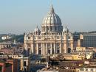

Figure 4: St. Peter’s Basilica

Art was so important to the Popes during the Renaissance era that some of the world’s most famous works of art were produced in the Sistine Chapel and St. Peter’s Basilica. Both are part of the Apostolic Palace, which is the official residence of the Pope. In 1984, Vatican City was added to UNESCO’s World Heritage List. It is the only listing that includes an entire state as a site of cultural importance and it is the only site recognized by UNESCO as a centre containing monuments in the “International Register of Cultural Property under Special Protection”.[18]

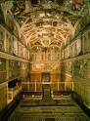

Figure 5: Sistine Chapel

### The Roman Catholic Church Government

The Roman Curia is the documentation that governs the entire Roman Catholic Church. It arranges and imparts the necessary central organization to ensure the Church functions properly. The Pope is the head of the Church and is seated in Vatican City, which is landlocked by Italy.[19] According to the Curia, the official Roman Catholic Church government appoints positions responsible for the upkeep of all church property, including bells and artifacts embedded in the floors of the churches. The committee who is responsible for cultural art found within the churches is called the Pontifical Commission for the Cultural Heritage of the Church. Today, Archbishop [Gianfranco Ravasi](http://www.catholic-hierarchy.org/bishop/bravg.html) is president of this committee.[20]

### Italian Government

Due to the massive amount of cultural heritage embedded in Italy, the Italian Government has established a specific branch dedicated to the preservation of Italian heritage. The branch is entitled the Ministry for Cultural Heritage (Ministero per i Beni e le Attività Culturali).[21]

### Venitian Government: Soprintendenza ai Beni Ambientali e Architettonici

The *Soprintendenza ai Beni Ambientali e Architettonici* is a subdivision of the Ministry for Cultural Heritage. This organization is responsible for overseeing cultural dealings in specific geographic areas under its authority. Venice, Italy has its own *Soprintendenza*, selected officials in charge of preservation of Venice. They are responsible for the protection of Venetian heritage through supervising any alterations made through restoration efforts to Venice’s monuments, art and landscape. UNESCO works in collaboration with the *Soprintendenza* to monitor how the funds from the Private Committees are used.[22] The *Soprintendenza* decide which pieces receive funding first depending on those in the most need of restoration. Archbishop Piana, who is second-in-command out of the *Soprintendenza* in Venice, describes his philosophy of prioritizing restoration efforts:

“first of all we dedicate resources to property that is under our direct tutelage (government property), secondly we have an open mind toward major properties, such as abandoned islands in the lagoon, thirdly we dedicate our attention to ecclesiastical buildings. The rest only gets minimum attention, except in case of imminent danger of complete loss of the artifact, in which case we intervene immediately.”[23]

The *Soprintendenza* also keep track of information collected about Venice through the Catalogue Office. The Offices is used to raise awareness about Venice to increase preservation efforts. Educating, guiding tours, and exhibitions are all ways the *Soprintendenza* inform people about Venice’s need for restoration.[24]

## Preservation of Venetian Heritage

### Flood of 1966

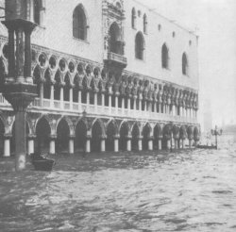

Figure 6: Flooded Doge’s Palace in St. Mark’s Square

On November 4, 1966, Northern Italy was hit with a devastating flood. Venice experienced water levels on average of 50cm that day, which came up to the shoulders of an average person. One hundred and fifty centimeters of water flooded the Doge’s Palace in St. Mark’s Square (Figure 6). More than 2,000 people in Venice evacuated their houses and more than 1,200 residents left Venice entirely. Over 75 percent of the stores and businesses were damaged. Even worse, the cultural heritage received so much damage, that there was no way of even calculating the damage.[25] Venice embodies massive amounts of Italian heritage through its public art, bells, and artifacts embedded in the floors of churches. The flood demonstrated the neglect of this historic city and caused a sense of urgency in the preservation of Venice to save the city from loosing its heritage. Many organizations responded internationally.

### UNESCO

The Flood of 1966 created a sense of urgency world wide and called much attention to the preservation of Venetian heritage. Since the flood, UNESCO has played a large role in preserving Venice through the Liaison Office for the Safeguarding of Venice. This office was founded in 1973, and a year before, a separate office was established, the UNESCO Scientific Co-operation Bureau for Europe (SC/BSE). Later in 1988, the Regional Office for Science and Technology for Europe (ROSTE) was relocated to Venice through a proposal from the Italian Government. UNESCO has an official office in Venice known as the UNESCO Regional Bureau for Science and Culture in Europe (BRESCE) located in Palazzo Zorzi. The main focus of this office is to handle issues relating to culture and science in the Member States in South-East Europe. This branch also works with the other UNESCO offices located in Central Europe and the Mediterranean basin. One of the main functions of this office is to contribute to the preservation of cultural heritage. In 2006, this office was officially named the UNESCO Office in Venice- UNESCO Regional Bureau for Science and Culture in Europe to demonstrate how important the preservation Venice is to UNESCO.[26] Even though Venice was the first whole city to be recognized by UNESCO as a site of cultural importance, Venice is the only site on the World Heritage list that doesn’t have management plan. In 2009, UNESCO hopes to host a World Café in hope of creating a management plan for Venice.[27]

UNESCO, the Superintendencies, and the International Private Committees have worked together in preservation efforts within Venice. UNESCO works with the Superintendencies and acts as a liaison that channels the money from the Private Committees to works of art in most need of restoration. In the past 39 years, the Private Committees have funded restorations for over 1,000 pieces of art and more than 100 monuments. The Associate of Private Committees is made up of a 30 member team with representation from 11 countries. In a three year period, the Association compiled over seven million euro which went to pay for 138 restorations and contribute to the on- going research and promotion of projects.[28]

### Private Committees

Many of the International Private Committees were formed, in favor of preserving Venice, as a reaction to the flood in 1966 through UNESCO’s program for Safeguarding Venice. In 1966, the British founded Venice in Peril, and the French established Comite Francais pour la Sauvegarde de Venise. Also, the United States helped out in restoration efforts through the organizations Venetian Heritage Inc. and America-Italy Society of Philadelphia. These committees responded to the flood by collecting money for the restoration of churches, bells and public art that were seriously damaged by the flood.[29] One of the largest contributors, Venice in Peril, has worked with the Superintendencies and UNESCO to restore more than 40 pieces of Venetian heritage since 1966. One source of Venice in Peril’s funding comes from W.H. Patterson Gallery who holds annual exhibitions of Venetian paintings. The Gallery donates a percentage of their profits to Venice in Peril. In one year, this gallery donated 88,130 U.S dollars to Venice in Peril.[30]



Figure 7: Venice in Peril logo

## Data Visualization Standards

With the onset of the Information Age and the 20th century the need to visualize data has become essential. The massive amounts of data available, while impressive, are not usable. Research has led to the development of tools and methods to assist in the display of data and information in usable and engaging ways. For our project we have choose to follow the Seven Stages of Data Visualization as described in O'Reilly's Data Visualization book. The first three stages involve acquiring the data, parsing the data into meaningful structures, and filtering out only the useful data. The last four stages, those we will be most involved with, are mining the data to discern patterns or context, representing the data in a simple visual model, refining the visual mode into a more engaging and clear display, and interacting with the data to increase usefulness. These stages provide a simple but effective method to create captivating and enticing visual displays. Progressing through each of these stages will help us develop the prototype that will increase awareness of and for the preservation of heritage.[31]

# Methodology

Our project is intended to raise awareness of and contribute to the maintenance of Venetian heritage by cataloging, organizing, and publishing interactive information. We will begin by organizing the existing data based on accepted standards. Then we will validate and expand the data specifically pertaining to bells and artifacts embedded in church floors. Once complete, we will develop a prototype system to easily display, manage, and maintain the data. Our efforts will be contained to accessible churches and bell towers within the Old City of Venice.

We plan to complete our mission through the following objectives:

1. To preserve embedded artifacts in church floors, bells, and public art by organizing existing data using The O'Reilly Data Visualization standards

2. To determine priorities of restoration using the organized databases

3. To determine, develop, and demonstrate an easy and efficient method to display, manage, and maintain the data

The rest of this chapter will be devoted to the following, and divided in the following manner:

Section 3.1 Preliminary Work

Section 3.2 Analyzing and Organizing Data

Section 3.3 Identifying Restoration Priorities

Section 3.4 Identifying Missing Information and future projects

Section 3.5 Develop and Demonstrate Prototype

## Preliminary Work

The proposal steps discussed below are relevant and necessary to for the successful completion of our project. The terms which we will be using for define the scope of our project throughout our paper are defined in the Domain of Inquiry section. The following section, Area of Study section, outline the physical areas of Venice we will be working in and with.

### *Domain of Inquiry and Definitions*

The following terms define the scope of our project:

Church: Any Roman Catholic Church in Venice, Italy.

Artifact: Any historically relevant object containing information that is found embedded in the church floors. These objects may include tombstones, plaques, and inscriptions.

### *Area of Study*

Our project will be contained within the boundaries of the Old City of Venice. Inside of the city we will focus on the embedded artifacts and bells residing within the churches covered by four previous Church Floors Projects. These projects cataloged roughly three-quarters the 142 Roman Catholic Churches on the six sestieri of Venice. Of the remaining churches, most were outside the main lagoon or otherwise inaccessible.

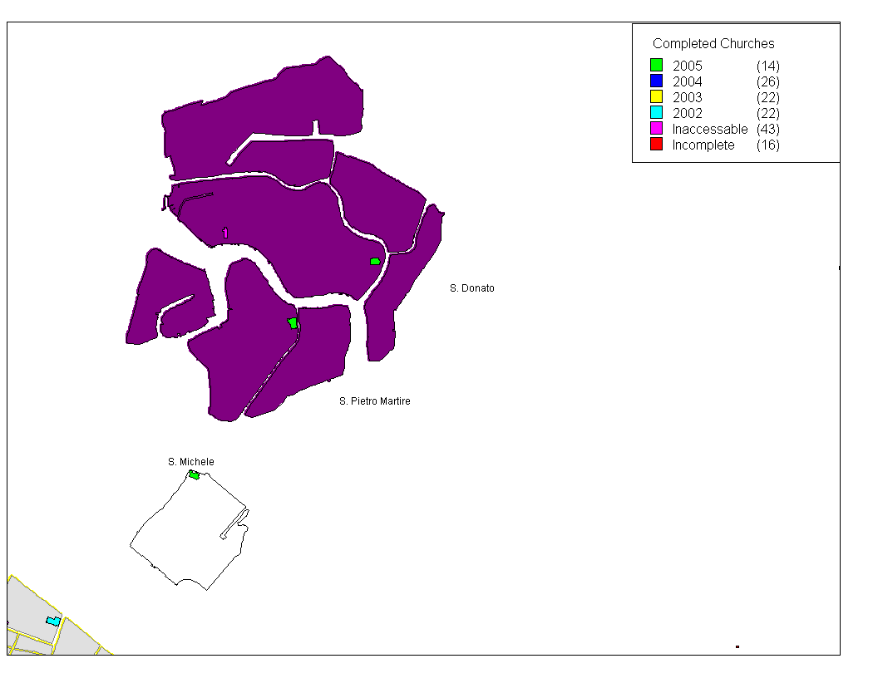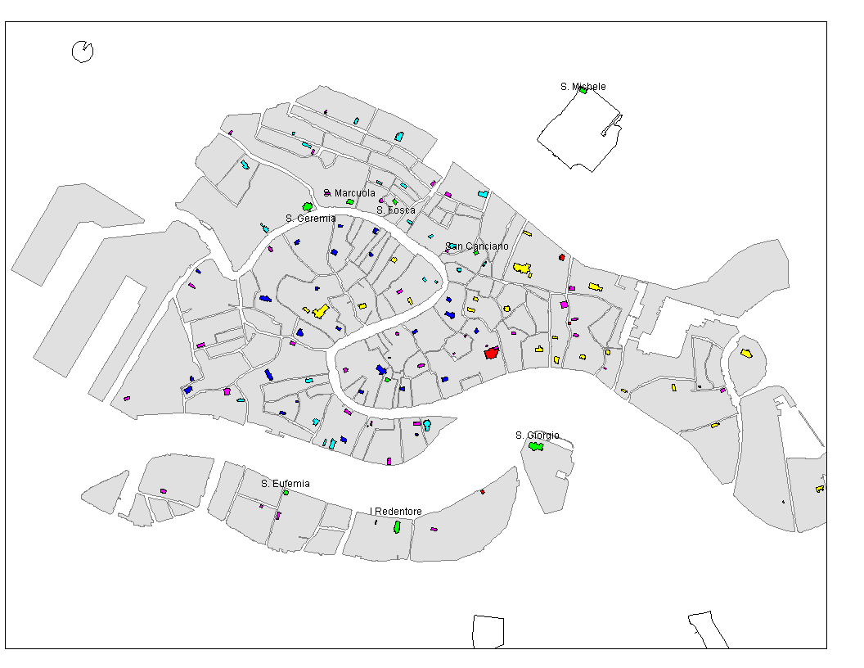

Figure 1: Comprehensive Area of Study

### *Access to Churches*

A crucial part of our project will be obtaining access to the churches and bell towers that host the artifacts and bells. Official letters briefly explaining the mission, goals, and potential outcomes of our project will be written to the Pastor of each church we will visit. If these letters do not grant us access to churches we will request a letter from Don Aldo Marongoni, a high ranking church official, to show to the church’s Pastor.

## Analyzing and Organizing the Data

Our project will contribute an organized and usable database consistent with the Data visualization standards outlined below. Also we will strive for quality and completeness in the database.

### Following O'Reilly Data Visualization Standards

The Seven stages of the Data Visualization, as outlined in the Background, will be the basis for our approach to restructuring the current disjoint databases into a cohesive unit. Through data mining, filtering, and refinement we will determine the underlying relationships among the data. These relationships will help us to determine how to restructure the data and create the new databases.

### Determine changes to current schema

Once the new structure has been determined, we will begin to implement the changes. While implementing the changes we will continue to reevaluate our database against the standards to further improve the end result.

### Analyze for Quality and Completeness

When we have achieved the optimum state of organization for our purposes we will began to interact with the data to determine its quality and completeness. When issues arise or information is deemed unimportant we will filter, mine, and refine the database. These cycles through the stages of visualization will assist us in achieving the more accurate results.

## Identifying Restoration Priorities

We will continue to us the systems of identifying restoration priorities developed by WPI students and Dr. Fabio Carrera for similar projects.

### Assessing Damage

Using our reorganized database we will be able to better interact with the data and develop or enact methods for assessing damage. Previous groups have designed and developed systems for assessing damage and we will incorporate these into our system. Thus allowing the system to be more usable as a restoration guide.

### Rankings

With the ability to assess damage and other attributes/ factors of the data comes the need to be able to order the data based off a given criteria. We will use previously mentioned algorithms and weighted scales to present the user with the ability to display ranked results. These results will allow for easy targeting of art in most need of restoration as well as oldest or more prevalent heritage. These ranked lists can be used to generate more awareness and thus increase preservation efforts world wide.

## Identifying Missing information and Future projects

Using the ranking systems developed in our previous objective we will be able to more efficiently determine missing information from the database.

### Determine Missing Attributes

Many of the previous projects have collected data on various aspects of heritage but as each new project was completed the information changed; whether it been old information removed, new information added, or just simply rewording / reorganization of the existing data. Without a uniform system much of the data is missing attributes or descriptors. Our system will highlight these omissions and allow for an easier update of the information.

### Determine Missing Entries (Artifacts or Bells)

Likewise to the missing attributes the system will help identify entries that are missing, such as a bell within a tower we could not obtain access to or a piece of art hidden from public view.

### Formulate possible future projects

With the ability to determine missing attributes and entries, projects to tackle these issues can be developed more quickly and efficiently.

## Develop and Demonstrate the Prototype

Following the organization of the data we will be able to develop the prototype for a system to manage and the maintain the data for future use and expansion. We will follow human computer interaction (HCI) principles and CRUD design principles. By following these principles our system will be more accessible and usable not only for those responsible for the restoration of heritage but also the average person concerned with preservation. Our prototype will serve as the model for all future preservation efforts.

### Obtain requirements from UNESCO for the World Cafe

Even though Venice was the first city to placed on the World Heritage List it still lacks the mandatory management plan. Because of this, UNESCO is pushing to have the World Cafe in 2009 help develop such a plan for Venice. We will contribute to UNESCO's efforts but obtaining their requirements for a management plan to basis our prototype around / on.

### Design and Implement Prototype

Once we have obtaining and analyzed the requirements we will begin to design our system around the requirements. We will use the database constructed in our first object as the content source for our system because it contains a wealth of knowledge valuable to all preservation efforts.

### Demonstration of Prototype

Once the system is constructed we will demonstrate it to all relevant parties.

# 

# Bibliography

“Venice and its Lagoon.” World Heritage. 1992. 22 Sept. 2008.

<http://whc.unesco.org/en/list/394>.

United Nations Educational, Scientific, and Cultural Organization. 1995. 23 Sept. 2008. <www.unesco.org/>.

Robinson, B.A. “Religions of the World.” Religious Tolerance. 1997. 23 Sept. 2008. <http://www.religioustolerance.org/worldrel.htm>.

PreserVenice. 2008. 15 Sept. 2008. <PreserVenice.org>.

“Venice Offices.” UNESCO. 1995. 26 Sept. 2008. <http://portal.unesco.org>.

“The Web Site of Venice.” Venetia. 21 Sept. 2008. <http://www.venetia.it/>.

Cheney, David. “Statistics by Country.” Catholic Hierarchy. 1996. 25 Sept. 2008. <http://www.catholic-hierarchy.org/country/sc1.html>.

Rizzardo, Ferdinando. “Soprintendenza B.A.P. di Venezia e Laguna.” Uministero per i Beni e le Attivita Culturali. 2000. 26 Sept. 2008. <http://www.soprintendenza.venezia.beniculturali.it/soprive/web-home/view?set_language=en>.

Venice in Peril. 2003. 22 Sept. 2008. <<http://www.veniceinperil.org/>>.

# Appendix A

## LITERATURE REVIEW/ANNOTATED BIBLIOGRAPHY

**Churches and Floors**

Delaive, Amanda; Kristant, Elaine; Petrowski, Craig; Santos, Luiz. The Church Floors in Venice, Italy: An Archeological Study and Analysis. Worcester: WPI, 2002.

This IQP is a great source; this will likely be a starting point in Venice on what to do with our project as well as outlining what holes we need to fill. The introduction and background contain factoids and areas of research to pursue further, and the bibliography points us in the direction of other sources.

Hayes, Hilary; Liu, James; Salini, Christian; Steinhart, Alexis. An Archeological and Analytical Study of Venetian Church Floors. Worcester: WPI, 2003.

This report gave us many background topics and factoids; it also expanded on data collection and organization techniques.

Blanchard, Scott; Caputo, Jeffrey; Regan, Matthew; Shaw, Matthew. An Analysis of the Archaeological Potential of Venetian Church Floors. Worcester: WPI, 2004.

This report will be useful, because it identifies a method to display data using MapInfo. It also began the process of organizing data using queries.

Thompson, Kelly; Gagnon, David; Ruscitti, Eric. Embedded Heritage: A Study of Venetian Church Floors. Worcester: WPI, 2005.

This report will be useful, because it identifies what data we will have to organize and manage. It also contains a method for ranking damage on a standardized 0-4 point scale.

“Venice Churches.” Sacred Destinations. 2005. 24 Sept. 2008. <http://www.sacred-destinations.com/italy/venice-churches.htm>.

Source of all churches in Venice and Italy- pictures of each and caption to go with each

FitzGerald, John; Mackenzie, Kathleen “The Preservation of Church Archives in Canada.” The Canadian Catholic Historical Association. 2003. 23 Sept. 2008. <http://www.umanitoba.ca/colleges/st_pauls/ccha/PresentationtoBishops.pdf>.

Bishops and preservation of church documents

Cheney, David. “Roman Curia.” Catholic Hierarchy. 1996. 25 Sept. 2008. <http://www.catholic-hierarchy.org/country/xcur.html>.

About church hierarchy; arranged by country

Cheney, David. “Statistics by Country.” Catholic Hierarchy. 1996. 25 Sept. 2008. <http://www.catholic-hierarchy.org/country/sc1.html>.

Statistics of Catholicism around the world; good factoids for number of catholics in Italy- demonstrating importance of religion

“The Roman Curia.” The Vatican. 24 Sept. 2008. <http://www.vatican.va/roman_curia/congregations/cbishops/>.

Roman curia; not very helpful because it was all in Italian.

Robinson, B.A. “Relegions of the World.” Relegious Tollerance. 1997. 23 Sept. 2008. <http://www.religioustolerance.org/worldrel.htm>.

Source was used to find statistics on major world religion. Useful in defining the global scope of religion.

**Bells and Towers**

Baker, Leonard; Carboni, Marina; Flores, Luis; Lanzillotti, Lisa. Cellular Bell Towers. Worcester: WPI, 2000.

This source creates an interesting idea that may be added into our methodology or possible suggestions. Their goal was to turn the bell towers that were falling into disrepair and give them a new purpose, so that people might be more motivated to see them fixed and fund their restoration.

Marion, Melissa; Milkin, Mike; Mill, Eric; Vitone, Chris. Preservation of Venetian Bell Towers. Worcester: WPI, 2004.

This IQP source focuses on Bell Towers versus Church Floors. This source works to catalog the towers and their condiotion and then analyzing. This form of catalog may prove useful for creating a database encompassing all past IQP information on Public Art in Venice.

Clouston, R. W. M. “The Welding of Cracked Bells.” Studies in Conservation Vol. 2, No. 4. Oct. 1956: 170-175.

This article explaned a method of preserveing cracked bells, by welding. It was shown that the weld did not change the tone of the bell considerable, and that the bells operational life can be expanded by possible more than 20 years.

Mason, James A. “Strengthening of a Historic Unreinforced Masonry Church Tower.” Practice Periodical on Structural Design and Construction. Feb. 2008: 31-38.

This article identifies a method of preserving historic building using an internal stiching of steel reinforcing bars, to support some of the dead weight, removing stresses from the cracked wall.

Modena, C.; Valluzz, M. R.; Tongini Folli, R.; Binda, L. “Design Choices and Intervention Techniques for Repairing and Strengthening of the Monza Cathedral Bell-Tower.” Construction and Building Materials Vol. 16, Issue 7. Oct. 2002: 385-395.

This article goes into greater detail on the inter reinforcement method of preserving historic buildings. The authors used acceleromiters in a similar method as prosed by past IQP groups, and used their results to formulate a possible preservation method.

**Preservation Groups**

United Nations Educational, Scientific, and Cultural Organization. 1995. 23 Sept. 2008. <www.unesco.org/>.

This website contains information on UNESCO, which is a active preservation group in Venice. It contains information on past restorations, and gives historical facts about UNESCO in relation to Venice.

“Venice Offices.” UNESCO. 1995. 26 Sept. 2008. <http://portal.unesco.org>.

This source gives up todate information regarding restoration efforts in Venice and other parts of the World.

World Monuments Fund. 2005. 27 Sept. 2008.

<http://wmf.org/?gclid=CMup46Te_JUCFRuuQAodnSfWEQ>.

Preservation group dedicated to preserving monuments and heritage world wide

“Venice and its Lagoon.” World Heritage. 1992. 22 Sept. 2008.

<http://whc.unesco.org/en/list/394>.

UNESCO sub-section which focuses on the preservation of sites with high cultural inportance.

PreserVenice. 2008. 15 Sept. 2008. <PreserVenice.org>.

This the website created by the 2007 IQP team for their organization PreserVenice

Venice in Peril. 2003. 22 Sept. 2008. <<http://www.veniceinperil.org/>>.

This is a British preservation group who finance restoration efforts in Venice.

**Content Management Systems**

Miller, R. “Open Source CMS Edges Toward the Mainstream.” Econtent. 2005: 28, 32-36.

Article describing why current opensource CMS systems and frameworks haven't made there way into the Business world and steps needed to be take to become enterprise management systems.

Feise, Joachim. “An Approach to Persistence of Web Resources.” Proceedings of the ACM Conference on Hypertext. 2001: 215-216.

This article address some the issues with dymanic nature of the world wide web and how create and maintain presistent data sources with revision history and read only access..

Boiko, B. Content Management Bible. New York: Hungry Minds, 2002.

Excellent resource on developing a maintainable and well organized CMS. Also explores and defines data and what it is manage data while outlining an easy follow framework for development. Scalable from the smallest to largest systems with detailed concepts.

Wright, Dawn J.; Goodchild, Michael F.; Proctor, James D. “GIS: Tool or Science? Demystifying the Persistent Ambiguity of GIS as "Tool" Versus "Science.’" Annals of the Association of American Geographers Vol. 87, No. 2. June, 1997: 346-362.

This article attempts to determine if GIS is a Science or Tool. Provides a chart comparing the different views and reasons for each argument. Conclusion is still undetermined but viewed more as a tool to assist science than as a science itself.

**Venice and Italy**

“The Web Site of Venice.” Venetia. 21 Sept. 2008. <http://www.venetia.it/>.

Site all about Venice from hotels; history and information about Italy in general

Rizzardo, Ferdinando. “Soprintendenza B.A.P. di Venezia e Laguna.” Uministero per i Beni e le Attivita Culturali. 2000. 26 Sept. 2008. <http://www.soprintendenza.venezia.beniculturali.it/soprive/web-home/view?set_language=en>.

Website of the Venetian Soprintendenza

.

1. <http://anthropology.tamu.edu/news.htm>
2. <http://www.cnn.com/2007/WORLD/asiapcf/05/10/afghan.buddhas/index.html>
3. <http://itotd.com/articles/495/the-sinking-city-of-venice/>
4. <http://www.veniceinperil.org/>
5. http://www.blackstudies.ucsb.edu/antillians/renaissance1.html
6. <http://www.ibiblio.org/wm/paint/glo/renaissance/it.html>
7. <http://statistica.regione.veneto.it/ENG/dati_settoriali_turismo.jsp>
8. <http://whc.unesco.org/en/list>
9. UNESCO http://whc.unesco.org/en/list
10. http://portal.unesco.org/en/ev.php-URL_ID=3978&URL_DO=DO_TOPIC&URL_SECTION=201.html
11. UNESCO http://portal.unesco.org
12. <http://www.veniceinperil.org>
13. PreserVenice.org
14. http://www.mapsofworld.com/olympic-trivia/number-of-participants.html
15. UNESCO http://whc.unesco.org/en/list
16. UNESCO http://whc.unesco.org/en/list
17. http://books.google.com/books?id=UbcOGwAACAAJ&dq=Italian+Renaissance
18. http://whc.unesco.org/en/list/91/
19. http://www.vatican.va/roman_curia/index.htm
20. http://www.vatican.va/roman_curia/index.htm
21. http://www.beniculturali.it/
22. http://www.soprintendenza.venezia.beniculturali.it/soprive/web-home/view?set_language=en
23. http://www.wpi.edu/Academics/Depts/IGSD/Projects/Venice/Center/Large_Files/MIT_Papers/What%20c ultural%20heritage%20do%20we%20preserve%20and%20why.pdf
24. http://www.soprintendenza.venezia.beniculturali.it/soprive/web-home/view?set_language=en
25. http://www.veniceword.com/news/9/acqua.html
26. http://portal.unesco.org/en/ev.php-URL_ID=1314&URL_DO=DO_TOPIC&URL_SECTION=201.html
27. http://venice2point0.blogspot.com/2008/07/saving-venice-with-unesco.html
28. http://portal.unesco.org/en/ev.php-URL_ID=1314&URL_DO=DO_TOPIC&URL_SECTION=201.html
29. http://portal.unesco.org/en/ev.php-URL_ID=1314&URL_DO=DO_TOPIC&URL_SECTION=201.html
30. http:// [www.veniceinperil.org](http://www.veniceinperil.org)
31. http://proquest.safaribooksonline.com/9780596514556